November 30, 2012

General Assembly Meeting

MLK Union- Effingham Room

**Call to Order:**

- 2:01

**Graduate Program Reports:**

* Dept. of Housing: Erasing the Distance performance next Wednesday, Dec. 5,

3:00 and 7:00

* Dietetics: new members coming next semester
* Comm Dept: Speech tournament Monday and Tuesday at 6
* KSS Updates: Graduate Research fair in McAfee Thursday 5-6:30

**President’s Report**:

* Meetings- especially about funding
* Council of Graduate Studies meeting
  + Grad Student involved with Williams Study Travel Grant

**VP of Administrative Activities Report:**

- Resigned

* + Thank you for all the work he’s done
* Looking for replacement- interested?

**VP of Programming Report:**

* Met with Lori about Grad school initiative
* Committee Meetings and updates
  + Spring events- a lot going on next semester!

**VP of Public Relations Report:**

* Jenna at conference
  + Report
    - Purchased business cards for org
    - Magnet business cards
    - Panther Palooza in January- will be looking for involvement

**Student Dean:**

* Committee meeting
* Grad School meetings for event dates next semester

**Advisors:**

* Lori and Bill attending conference in DC for National Graduate Schools
  + Dean Augustine will be a speaker talking, in part, about GSAC
  + Reception for alumni in the DC area hosted by EIU Grad School

**Committee Reports:**

* Finance
  + Student Fee Conversation- mainly a Spring Semester project
  + Quality of Life Survey dates nailed down
    - Mid- January so we can get the info by early Feb
  + Archive project- to be completed over Christmas break
* Programming
  + Providing some snacks for finals week to hand out
  + December social- Dec. 7 from 8pm-10pm
    - Mike and Stan’s on Monroe
      * Food provided and special bartender
  + Volunteer Opportunity in the community
    - Toys for Tots boxes- collecting new toys, gently used coats, hats, scarves, and bedding (especially twin sized).
      * SEE ATTACHED FOR MORE INFORMATION
  + Send Nicole ideas for volunteering in the community next semester

* Orientation Committee
  + 50 things to do in Charleston area list completed

**Open Floor:**

- GA’s larger inbox- John in Communication Studies starting to look into this

**New Business**:

* Election plan for VP of Administrative Activities
  + Advertising for next semester
  + Special session to elect new official
* Meeting time for next semester
  + Friday still looking like the best time
    - Maybe changing the time to not mid-day
    - Sending out Doodle to see what time works best
  + May change meeting to once a month instead of every 3 weeks
* Grad School Initiative- Mentoring program
  + Use grad student voices to talk to undergrads
    - Looking for volunteers to help mentor undergrad- informal, coffee meeting, just to answer questions undergrads may have
  + Event in Spring that undergrads can come to and talk to grad students
  + Looking for ideas on how to effectively talk to undergrads- suggestions appreciated!

**Next Meeting:**

- January! Have a great break!

**Adjournment:**

* 2:31

**C:\Users\Nichole\AppData\Local\Microsoft\Windows\Temporary Internet Files\Content.IE5\JGZBYY9B\MC900232951[1].wmf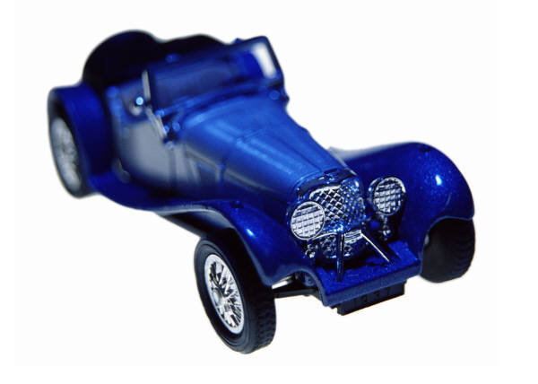Collecting:**

**Toys**

**Used Coats, hats, and scarves**

**Used Twin Size Blankets and Bedding**

**Until Friday, December 7th**

**Places to drop off donations:**

**Facilities Planning & Mgmt.  
  
Special Ed, 1212 Buzzard Hall  
  
Health Services, Human Services Bldg  
  
Office of Registrar, 1150 Old Main  
  
Counseling Center, Human Services Bldg – Coat Drive Only  
  
Academic Advising, 9th Street Hall  
  
Business Office, 1137 Old Main**

**Coleman Hall, History Tutoring Center Rm. 2726**

**Thank You!**