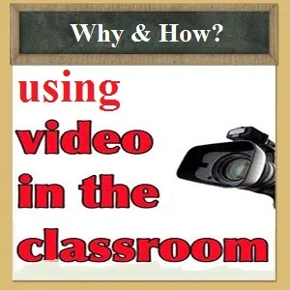

Best practices for using video / media in education

Tools Planned to Discuss/Try
- LunaNotes - https://lunanotes.io/
  - personal timestamping and notes
- Vibby - https://www.vibby.com/create/1
  - create highlight reels
    - inserting objective & select sections to view
    - Example https://www.vibby.com/v/m1lx8Gr3kx
- EdPuzzle - https://edpuzzle.com/
  - one of the top tools used by teachers
  - insert questions and assign video including grading
- Google Classroom “new” feature for Education Plus edition
  - works with YouTube and assignments to embed questions
- Video Ant - https://ant.umn.edu/
  - University of MN - developed classroom collaboration timestamping and commenting/notes

