Artificial Intelligence
What Educators Should Know

VIDEO of February 23rd Presentation by Joe Fatheree - LINK
joesphfatheree@gmail.com
Effingham H.S. - Instructor of Creativity and Innovation
2007 Illinois Teacher of the Year
Top 10 Finalist for Global Teacher Prize

Director of EIU Rural School Initiative
bdreid2@eiu.edu

Local Hero – Besides Joe Fatheree who is internationally recognized we have Lisa Coburn at Westville CUSD #2 who was featured by ISTE as one of the K-12 AI Explorers.
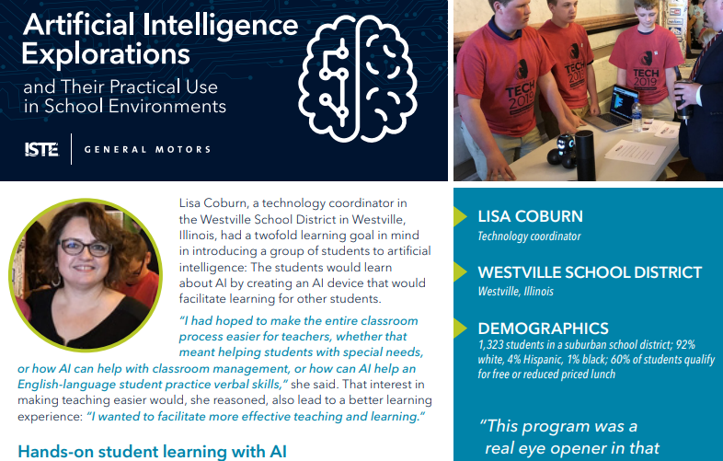

From the Illinois P-12 Computer Science Standards adopted January 2022.
The following standards are a modified version of the K-12 Computer Science Framework and introduce standards for "emerging technologies" as a dynamic field that can contribute to many future technologies. Examples of emerging technologies currently include, but are not limited to, artificial intelligence, quantum computing, augmented reality, and applications of robotics. Teachers and students are given freedom to decide how to incorporate the future of computing into their classrooms. Within each grade band standards, this domain comprises a general progression of competencies that students should have across grade levels. These are duplicated and presented in each grade band.

Algorithms and Programming
Algorithms
11-12.AP.10 Describe how artificial intelligence drives many software and physical systems.
11-12.AP.11 Implement an artificial intelligence algorithm to play a game against a human opponent or solve a problem.
11-12.AP.12 Use and adapt classic algorithms to solve computational problems.

AI Projects for the Classroom - ISTE Hands-On Guides (free)
Elementary, Secondary, Exploratory Elective, Computer Science, and Ethics
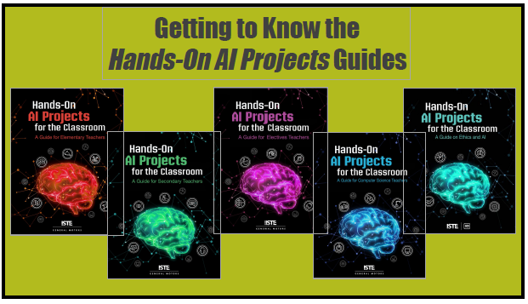

A few major generative AI systems now making news
- ChatGPT – GPT means “generative pre-trained transformer”
- Harvey (harvard law takeoff) - generates legal policies and contracts.
- Dall-E-2 - generates images from verbal description - “show two turtles wearing sunglasses with drinks on a rock using Monee style”
- AlphaFold - in a year solved 200 million known protein structures and how their bonds fold for function. This will move the pharmaceutical industry forward by decades.

Simple example. EIU Rural School Initiative needed an AUP for off campus GYO Cohort students to be able to check out laptops for class use. Tried using ChatGPT to create a policy using the prompt:
write an acceptable use policy for college students to check out laptops to use off campus
Starter Document to modify as needed. Produced with the formatting in the document

TRAINING AI Bots – short explanation of how it works
if it’s testable, it’s teachable
Just FYI, all those Captcha tests to identify all pictures with a bridge or with a stoplight … those can be used to train self-driving cars

Hands on Activities to let students experience training AI

Teachable Machine - Google Experiments free activity for students. Conduct your own Machine Learning Activity and download your code
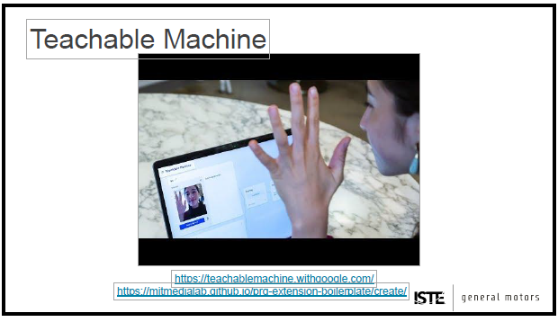

Google Vision API - programming toolkit to practice and even develop your own routines to use in projects. FREE, but they do file a credit card.
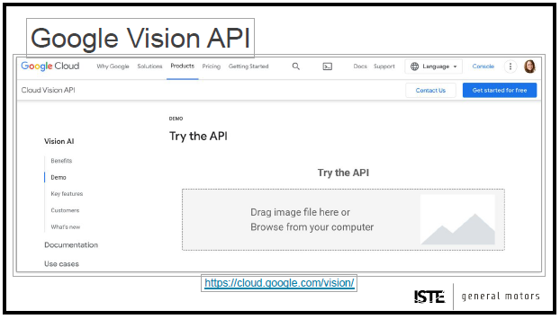

What to do?

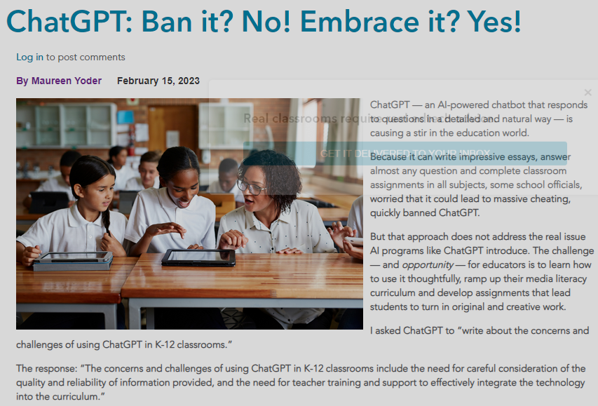

International Day of AI somewhat like Hour of Code
2023 will be May 18th - Bring Day of AI to your classroom in 2023!
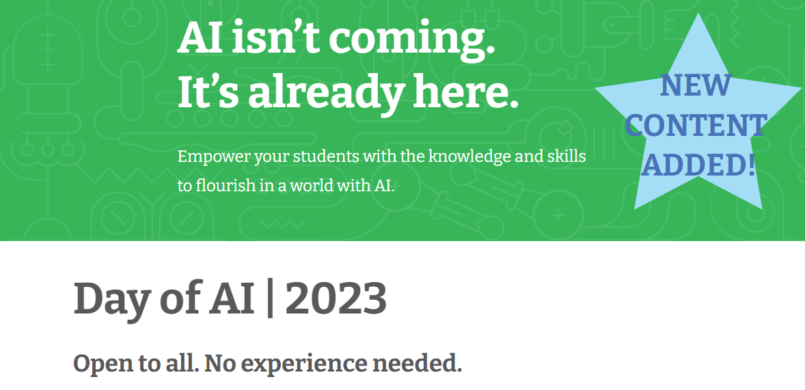

A few more resources
- https://ai.google/education/
- https://ai4k12.org/
- https://www.iste.org/areas-of-focus/AI-in-education
- https://sites.google.com/docs.iste.org/isteaiandstemnetwork/home

LINK to this document itself

