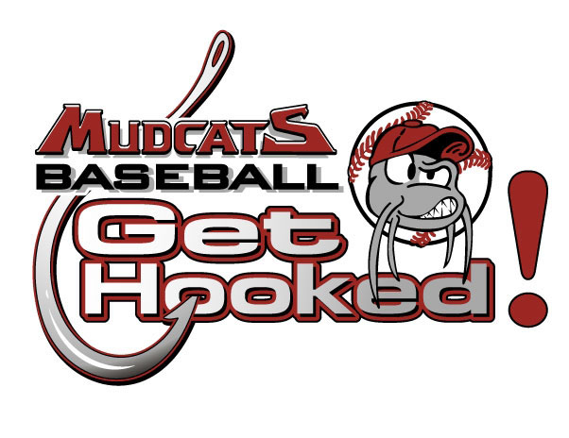
Summer 2024 Internship

QUALIFICATIONS
Do you have what it takes to be a Chillicothe Mudcats intern? We’re looking for talented, self-motivated individuals who want to learn what goes on behind the scenes of high-level collegiate summer baseball organization. We value open-minded, conscientious team players possessing a positive attitude and a willingness to do what it takes to get the job done. Must possess great writing, computer skills and a willingness to work long hours and weekends. If this is you, we look forward to talking with you. Anyone interested or seeking more information should send their resume to Ronda Payne at travel4mom@hotmail.com
JOB DESCRIPTION
Home games you will work in multiple areas; including but not limited to game day set up and tear down, souvenirs sales, ticket sales and on-field promotions.
Promote upcoming events, theme nights and games via Social Media platform.
Organize and execute nightly promotions and theme nights, with the goal of a fun experience for our fans.
Any other task assigned by the Front Office Staff.
Take pictures during games of groups, fans in the stands and special events.
START DATE
Start in late-May and end on July 21 (start and finish dates are flexible).

