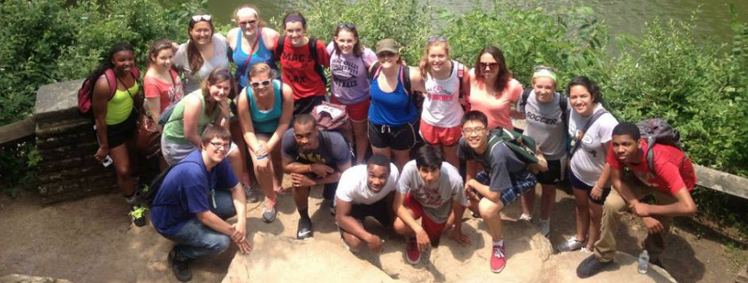
Eastern Illinois University
High School Journalism Camp Application

A
BOUT THE PROGRAM: The EIU High School Journalism Camp is a 6-day residential program that provides students an intimate look at journalism as a career. The camp introduces students to the complete process of publishing news: gathering and validating information, substantiating and using multiple sources, writing news, editing, designing, and production. In addition, students are exposed to the concepts of news literacy and how to differentiate and establish fact from fiction in today's sometimes frenetic, rush-to-report news environment. This year’s workshop takes place July 9 - 14, 2023. Graduating seniors are eligible to participate. The cost to attend is $100 per camper.

NAME _____________________________________________________________________________ AGE ____________

STREET _____________________________________________________________________________________________

CITY ______________________________________________ ZIP ______________________ SHIRT SIZE ______________

HOME PHONE ________________________________ CELL PHONE __________________________________________

EMAIL ____________________________________________________________________________________

PARENTS’ NAMES _________________________________ PARENT PHONE _____________________________________

SCHOOL _____________________________________________________ GRADE IN FALL 2023 ___________________

GPA IS _________ ON _______ SCALE WORKED ON HS MEDIA & TYPE. Yes No Yearbook. Newspaper Radio

ETHNICITY (circle one) African-American Hispanic Asian-American Caucasian Other

SEND THIS FORM TO Betsy Jewell, c/o EIU Journalism Dept., 600 Lincoln Ave., Charleston, IL 61920 or email to cejewell@eiu.edu. Deadline is June 8, 2023. Don’t forget to also submit a personal essay (reasons for wanting to attend this camp and future goals) with this application. Recommendation letters can be sent afterward – so long as they are received by the deadline above.

