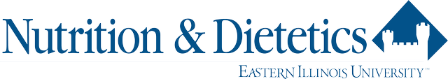

Dietetic Internship
2022 Virtual Open Houses

Find out more about EIU’s Dietetic Internship and Master of Science Nutrition & Dietetics Program

Friday, September 2, 2022
1:00pm – 2:30pm
Join us online at:
https://eiu.zoom.us/j/93772086038
Meeting ID: 937 7208 6038

Friday October 21, 2022
1:00pm – 2:30pm
Join us online at:
https://eiu.zoom.us/j/99437918954
Meeting ID: 994 3791 8954

1:00 Welcome and Overview of Program
1:30 Q & A with current Interns
2:00 Q&A with the Director and GAs

PLEASE RSVP to
Melissa Maulding, MS, RDN
DI Coordinator
Mkmaulding2@eiu.edu
Phone: (217) 581-7571

