Eastern Illinois University
Communication Disorders and Sciences &
East Central Illinois Speech–Language-Hearing Association
2017 Fall Autism Conference

Update on Autism Spectrum Disorders: Etiology and Intervention Strategies

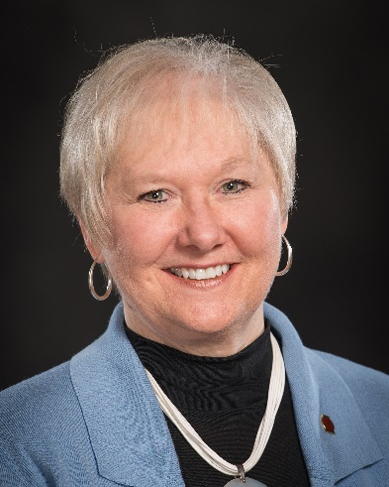
Where: Eastern Illinois University
University Union Ballroom
When: Friday, September 29, 2017
9:00 a.m. – 3:00 p.m.
Fee: Professionals -$50.00
Students - $10.00
Registration: Go to www.eiu.edu/commdis/ to register or contact Sandi Thiele at
(217) 581-2712

Autism Center T-shirts are available for purchase. There is a link to purchase on the same online website used for registration. T-shirts must be ordered by September 1 to be available for pickup at the Conference.

Gail J. Richard, Ph.D., CCC-SLP
Professor Emeritus of Communication Disorders & Sciences
Autism Center Director, Eastern Illinois University
President, American Speech-Language-Hearing Association

Agenda
9:00-12:00am: Overview of characteristic profile of autism spectrum disorder
- Definition and diagnostic criteria of Autism Spectrum Disorder (ASD).
- Research regarding etiological theories for ASD.
- Discussion of major behavioral characteristics associated with ASD
12:00-1:00 Lunch Break (on your own.)
1:00-3:00pm: Intervention Strategies for ASD
- Sensory system and behavior strategies
- Communication and social skills assessment and strategies
- General classroom and management strategies

Learning Outcomes
After attending this conference, participants will be able to:
- Define diagnostic criteria and describe primary behavioral characteristics of ASD.
- Summarize major research findings regarding etiology of ASD
- Generate strategies to address sensory-based behavior challenges
- Implement assessment and intervention strategies to address communication and social challenges within ASD

This course is offered for .5 ASHA CEUs (professional area, intermediate level)
5 hours EI Credit Atypical Development
Disclosure: Financial: Dr. Richard has multiple publications for which she receives royalties.
Nonfinancial: Dr. Richard serves as President of ASHA and is Director of the Autism Center at EIU.

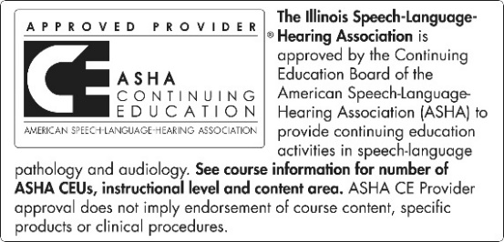
An annual ASHA CE Registry fee is required to register ASHA CEUs. ASHA CE Registry fees are paid directly to the ASHA National Office. To register CEUs with ASHA, you must complete a CE participant form, turn it in at the time of the activity, and pay the ASHA CE Registry fee. ASHA CEUs are awarded ONLY AFTER receipt of the CE Participant Form AND payment of the Registry fee.

