COLLEGE OF HEALTH AND HUMAN SERVICES
CURRICULUM COMMITTEE MEETING AGENDA

February 10, 2020
1418 Klehm Hall at 2:00 p.m.

- Approval of Minutes:
- Minutes of the December 2, 2019 meeting.

- Communications:
None.

- Items to be Acted Upon:
- 20-01, B.S. in Public Health: Community Health Option (Revised Option)
- 20-02, NTR 3756, Community Nutrition Interventions (Revised Course)
- 20-03, B.S. in Nutrition & Dietetics (Revised Major)

- Discussion of Article VI., sections 6.01 and 6.04, of the Committee’s Bylaws:

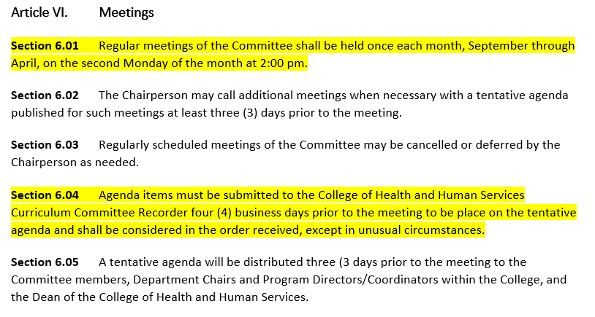
- Pending:
None.

- CAA/CGS/COTE Update:
Items in Process:
Executive Action Requests:
- Amend the course description and prerequisites for HSL/HPR/PBUH 2800.
- Update the catalog language for the B.S. in Nursing (Traditional Program) admission and progression requirements.
- Revise the course descriptions for NTR 1120, 1121, 2750, 3120, 3500, 3755, 4275, 4230, 4749, 4750, 4753, 4757, and 4940.

Approved Items:
Proposals:
- New Courses: NUR 1511, 2612, 2712, 2822, 2823, 3413, 3513, 3612, 3712, 3813, 3833, 3835, 3836, 4412, 4413, 4513, 4534, 4636, and 4735. (Proposals approved – 9/5/19 CAA)
- Revised Course: NUR 2613 (Proposal approved – 9/5/19 CAA)
- New Program: Reasonable and Moderate Extension of the Nursing Program to create a Traditional BSN Program and a School of Nursing. (Proposal approved – 9/5/19 CAA)
- Program Revision: M.S. in Health Promotion & Leadership (Proposal approved - 9/17/19 CGS)
- Apply the course number change for NUR 3203 to NUR 2613 to the Health Promotion: Community Health Option, Health Promotion: Emergency Management & Disaster Preparedness Option, Exercise Science: Pre-Occupational Therapy Option, Exercise Science: Pre-Physical Therapy Option, Recreation Administration: Therapeutic Recreation Option, and Nutrition & Dietetics. (Proposal approved – 9/19/19 CAA)
- Revised Department, Major, and Minor Names: Health Promotion department name to Public Health, change the major name to B.S. in Public Health, and update the names of the minors to Public Health Minor and Public Health Minor for Teacher Licensure. (Proposal approved – 10/31/19 CAA)
- Change the Health Promotion course prefix from HPR to PBH and the Banner major/program codes for the Health Promotion programs. (Proposal approved – 10/31/19 CAA) Request superseded by action taken at a later date. See number 9 below.
- Revised Course: REC 4710 (Proposal approved – 10/31/19 CAA)
- Revised Program: B.S. in Recreation Administration: Therapeutic Recreation Option (Proposal approved – 10/31/19 CAA).
- New courses: HSL 3220, HSL 4220, and HSL 4225 (Proposal approved – 1/23/20 CAA)
- New Minor: 19-43, Early Childhood Program Administration Minor (Proposal approved – 1/23/20 CAA)
- Revised Course: HPR (PUBH) 3200: School Health for K-12 Teachers (Proposal approved – 1/23/20 CAA)
- Revised Minor: Aging Studies Minor (Proposal approved – 1/23/20 CAA)
- Revised Course: NTR 2100 (Proposal approved – 1/23/20 CAA)
- Revised Course HPR/PUBH 3200 (Proposal approved – 1/23/20 CAA)
- Revised Program: M.A. in Aging Studies and Accelerated Graduate Program (Proposal approved – 2/4/20 CGS) Note: An executive action request to approve the revisions to the accelerated program were approved by CAA on 1/16/20. See number 6 below.

Executive Action Requests:
- Revise the enrollment restrictions for EIU 4151G. (Executive Action approved - 9/5/19 CAA)
- Revise the course title for HPR 3200. (Executive Action approved - 9/5/19 CAA)
- Modify the course class time for NTR 5150 and NTR 5154 from (3-0-3) to (3-1-3.) (Executive Actions approved - 9/17/19 CGS)
- Add HSL 4775 to the Accelerated Graduate Program for the M.S. in Human Services Program Administration. (Executive Action approved - 9/17/19 CGS and 9/19/19 CAA)
- Update the number of dietetics core and elective hours in the Nutrition & Dietetics graduate degree program. (Executive Action approved - 10/15/19 CGS)
- Revised the Aging Studies accelerated program (Executive Action approved - 1/16/ 20 CAA) Note: CGS is handling the request as a proposal. See number 16 above.
- Delete HPR 3000 from the catalog. (Executive Action approved - 12/5/19 CAA)
- Remove the course restrictions from HSL 4775. (Executive Action approved - 2/4/20 CGS; Pending CAA approval)
- Change the Public Health (Health Promotion) course prefix from PBH to PUBH. (Executive Action approved - 12/5/19 CAA and 2/4/20 CGS) Supersedes an earlier action. See approved proposal number 7 above.
- Change the course prefix for FCS 5230 to NTR 5230. (Executive Action approved - 2/4/20 CGS)
- Revise the departmental admission criteria for the Sports Administration and Exercise Physiology graduate degree programs. (Executive Action approved - 2/4/20 CGS)

