Eastern Illinois University
New/Revised Course Proposal Format
Agenda Item #18-02
Effective Spring 2019
(Approved by CAA on 4/3/14 and CGS on 4/15/14, Effective Fall 2014)

Banner/Catalog Information (Coversheet)
- __X__New Course or _____Revision of Existing Course

- Course prefix and number: __HPR 4555__________________________
- Short title: __Health Promotion Honors Research_______________
- Long title: ___Honors Research_____________________________________________
- Hours per week: __3_ Class _0__ Lab _3__ Credit
- Terms: ___ Fall ___ Spring ___ Summer _X__ On demand
- Initial term: ___ Fall __X_ Spring ___ Summer Year: __2019____
- Catalog course description: In consultation with a faculty supervisor, the student designs, executes, and writes the results of an original piece of research using primary data. Any appropriate research methodology may be employed. The student must submit a detailed study proposal to be approved by the faculty supervisor and the Departmental Honors Coordinator prior to registration. The product may be applied to SPC 4644, Honors Thesis.
- Course attributes:
General education component: ____N/A_____________________________________________
___ Cultural diversity _X_ Honors ___ Writing centered _X_ Writing intensive ___Writing active
- Instructional delivery
Type of Course:
___ Lecture ___ Lab ___ Lecture/lab combined _X__ Independent study/research
___ Internship ___ Performance ___ Practicum/clinical ___ Other, specify: ________________
Mode(s) of Delivery:
_X__ Face to Face ___ Online ___ Study Abroad
__ Hybrid, specify approximate amount of on-line and face-to-face instruction: Minimum of 33% of class time will be face-to-face.
- Course(s) to be deleted from the catalog once this course is approved. None
- Equivalent course(s): ___HST 3800______________________________________________
  - Are students allowed to take equivalent course(s) for credit? ___ Yes _X__ No
- Prerequisite(s): ___HST 2800_______________________________________________
  - Can prerequisite be taken concurrently? ___ Yes _X__ No
  - Minimum grade required for the prerequisite course(s)? _C__
  - Use Banner coding to enforce prerequisite course(s)? _C__ Yes ___ No
  - Who may waive prerequisite(s)?
___ No one _X__ Chair ___ Instructor ___ Advisor _X Other (specify) Honors Coord.
- Co-requisite(s): None
- Enrollment restrictions
  - Degrees, colleges, majors, levels, classes which may take the course Degrees: Health Promotion: CH; Health Promotion: EMDP; Health Administration; Health Communication. Minors: Community Health, Health Communication
  - Degrees, colleges, majors, levels, classes which may not take the course: all others
- Repeat status: _X__ May not be repeated ___ May be repeated once with credit
- Enter the limit, if any, on hours which may be applied to a major or minor: 3 s.h.
- Grading methods: __X_ Standard ___ CR/NC __ Audit ___ ABC/NC
- Special grading provisions: N/A
___ Grade for course will not count in a student’s grade point average.
___ Grade for course will not count in hours toward graduation.
___ Grade for course will be removed from GPA if student already has credit for or is registered in: ________________________________________________________________
___ Credit hours for course will be removed from student’s hours toward graduation if student already has credit for or is registered in: ____________________________________
- Additional costs to students:
Supplemental Materials or Software None
Course Fee _X__No ___Yes, Explain if yes________________________________
- Community college transfer:
___ A community college course may be judged equivalent.
__X_ A community college may not be judged equivalent.
Note: Upper division credit (3000+) will not be granted for a community college course, even if the content is judged to be equivalent.

Rationale, Justifications, and Assurances (Part I)
- _X__Course is required for the major(s) of HPR: CH; Health Administration
___Course is required for the minor(s) of ____________________
___Course is required for the certificate program(s) of ______________
_X__ Course is used as an elective HPR: EMDP; Health Communication
- Rationale for proposal : This course proposal is part of a package of course proposals to support the newly created Health Promotion Department Honors Program. Completion of this course replaces completion of HST 3800: Research Methods II in the curriculum for students admitted to the Department Honors Program.
- Justifications for (answer N/A if not applicable)
Similarity to other courses: This course is similar to HST 3800: Research Methods II, but is specifically designed to provide an Honors version of the content in HST 3800.
Prerequisites: Prerequisites are necessary to limit enrollment to HPR Dept. Honors students, and to ensure students are prepared to conduct their own individual research project.
Co-requisites: none
Enrollment restrictions: Only students admitted to the HPR Dept. Honors Program will be allowed to enroll.
Writing active, intensive, centered: Writing intensive. Several writing assignments and writing activities are required in this course. At least one writing assignment is to be revised by the student after it has been read and commented on by the instructor. Student’s writing will constitute no less than 35% of the final course grade.
- General education assurances (answer N/A if not applicable) N/A
General education component: N/A
Curriculum: N/A
Instruction: N/A
Assessment: N/A
- Online/Hybrid delivery justification & assurances (answer N/A if not applicable)
Online or hybrid delivery justification: N/A
Instruction: N/A
Integrity: N/A
Interaction: N/A

Model Syllabus (Part II)
Please include the following information:
- Course number and title HPR 4555: Honors Research
- Catalog description: In consultation with a faculty supervisor, the student designs, executes, and writes the results of an original piece of research using primary data. Any appropriate research methodology may be employed. The student must submit a detailed study proposal to be approved by the faculty supervisor and the Departmental Honors Coordinator prior to registration. The product may be applied to SPC 4644, Honors Thesis.
- Learning objectives. By the end of this course, the student will be able to:
  - Evaluate research designs, methodology, and findings from research literature.
  - Assess strengths and limitations of qualitative and quantitative research methods.
  - Identify and design a research methodology appropriate to answering the stated thesis research problem, and any accompanying hypotheses.
  - Execute the research design, collecting primary data, and in full compliance with IRB requirements.
  - Analyze and evaluate their primary data.
  - Determine the significance of their research.
  - Design and created a poster presentation and abstract suitable for a specific professional audience.
- Course materials. No required text. Student will use appropriate primary and secondary sources.
- Weekly outline of content.

As Honors Research, student and faculty mentor will build on the foundational content found in HST 3800: Research Methods II, and described below, to customize and augment the student’s experience. The Honors student will be expected to complete a more comprehensive and intensive research project.
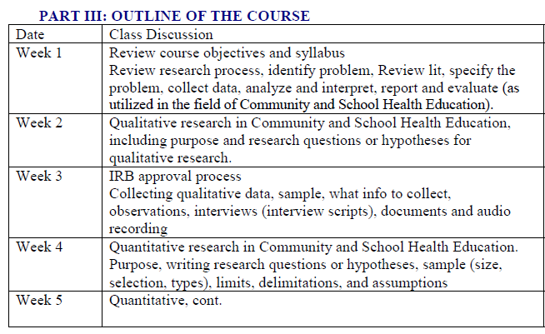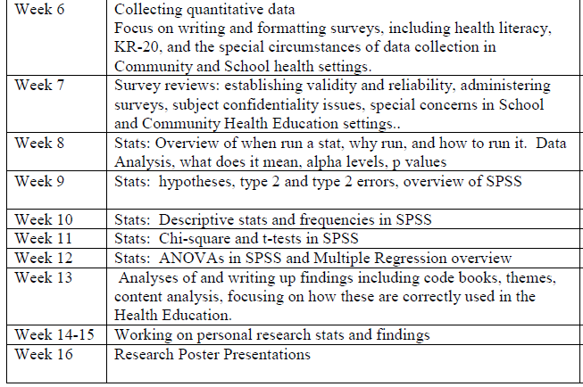

- Assignments and evaluation, including weights for final course grade.
  - Research Methodology (30%)
  - Data collection instrument (20%)
  - Data Analysis (20%)
  - Findings (30%)

- Grading scale.
90%+ A
80-89% B
70-79% C
60-69% D
<60% F

- Correlation of learning objectives to assignments and evaluation.

Assignment | Obj. A | Obj. B | Obj. C | Obj. D | Obj. E | Obj. F | Obj. G
Research Methodology | X | X | X |  |  |  | X
Instrument |  |  |  | X |  |  | X
Data Analysis |  |  |  |  | X | X | X
Findings |  |  |  |  | X | X | X

Date approved by the department or school: 10/15/2018
Date approved by the college curriculum committee:
Date approved by the Honors Council (if this is an honors course):
Date approved by CAA: CGS:

