General Education
Assessment of Student Learning
With the creation of the General Education Sub-Committee of the CAA in Fall 2019 and appointment of a program coordinator, the locus of control for the program and assessment of student learning resides with the sub-committee. The sub-committee has been charged with drafting an assessment plan in AY19-20 that builds on and extends on the extensive and important prior work of the Committee for the Assessment of Student Learning, as well as the annual summaries prepared by the Academic Success Center. Year 1 of the new committee’s assessment cycle begins with the 2020-2021 Academic Year. The first two year report will be due in October 2021.
The assessment cycle at EIU requires the development of an assessment plan, annual data collection, and regular faculty engagement in the analysis of data on student outcomes. As such, assessment is an annual process of continuous improvement and refinement of academic programs, as well as learning outcomes. From a compliance perspective, all academic programs, including the general education program, will engage in a biennial review process. This biennial review process will require reports in Years 2 and 4 that include administrative review and feedback. Year 4 reporting and feedback will be more detailed and extensive. The compliance reports will be due to the Executive Director of the Academic Success Center no later than October 15 or the first business day thereafter. The materials will be archived online by the Academic Success Center.

Figure 1. Assessment as Continuous Improvement
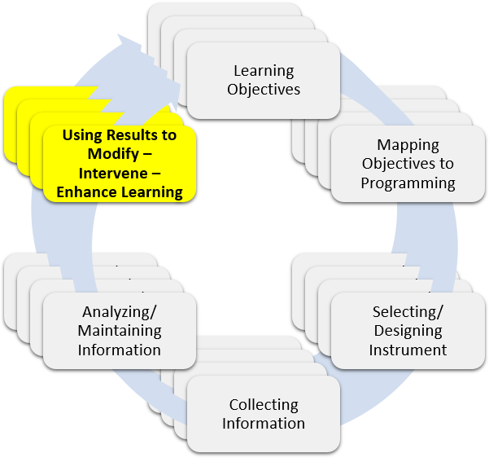

Annual Summaries
The Academic Success Center will coordinate the collection of data in consultation with the General Education Committee, as well as content area stakeholders, and produce an annual summary of the five University Learning Goal domains. These domains are: Speaking and Listening Across the Curriculum; Quantitative Reasoning; Critical Thinking; Writing and Critical Reading; and Responsible Citizenship.
Year 2
The General Education Committee is required to submit the Year 2 Assessment Template. Additionally, the submission must include a Summary of the Assessment Data by ULG as an appendix. The General Education Director may also include an optional cover memo (not to exceed 1 page). The cover letter might include any information or highlights the committee believes would be important to demonstrate academic excellence and program quality.
The submitted materials will be reviewed by the Assessment Coordinator and feedback shared with the CAA, as well as the posted online. The program report and feedback will be archived by the Assessment Coordinator.
Year 4
The General Education Committee is required to submit a completed Year 4 Assessment Template and a Summary of the Assessment Data by ULG for the past 4 Years. The optional cover memo (not to exceed 1 page) may include any information or highlights the committee believes would be important to demonstrate academic excellence and program quality.
The submitted materials will be reviewed by the Assessment Coordinator and by the VP for Academic Affairs and archived.

Year 2
University Learning Goals – General Education
EIU’s University Learning Goals ensure that:
1. EIU graduates question, examine, evaluate, and respond to problems or arguments.
2. EIU graduates write critically and evaluate varied sources.
3. EIU graduates prepare, deliver, and critically evaluate presentations and other formal speaking activities.
4. EIU graduates produce, analyze, interpret, and evaluate material.
5. EIU graduates make informed decisions based on knowledge of the physical and natural world and human history and culture.

Overview of Measures/Instruments
ULG(s)  Note: Measures might be used for more than 1 ULG | Measures/Instruments  Please include a clear description of the instrument including when and where it is administered | How is the information Used?  (include target score(s), results, and report if target(s) were met/not met/partially met for each instrument)

Improvements and Changes Based on Assessment
1. Provide a short summary (1-2 paragraphs or bullets) of any curricular actions (revisions, additions, and so on) that were approved over the past two years as a result of reflecting on the student learning outcomes data. Are there any additional future changes, revisions, or interventions proposed or still pending?
2. Please provide a brief description or bulleted list of any improvements (or declines) observed/measured in student learning. Be sure to mention any intervention made that has not yet resulted in student improvement (if applicable).
3. Using the form below, please document annual faculty and committee engagement with the assessment process (such as the review of outcomes data, revisions/updates to assessment plan, and reaffirmation of SLOs).
History of Annual Review
Date of Annual Review | Individuals/Groups who Reviewed Plan | Results of the Review (i.e., reference proposed changes from #1 above, revised measures, etc...)

Assessment Coordinator Review & Feedback

_______________________________________________ ____________________
Assessment Coordinator Date

Year 4
University Learning Goals – General Education
EIU’s University Learning Goals ensure that:
1. EIU graduates question, examine, evaluate, and respond to problems or arguments.
2. EIU graduates write critically and evaluate varied sources.
3. EIU graduates prepare, deliver, and critically evaluate presentations and other formal speaking activities.
4. EIU graduates produce, analyze, interpret, and evaluate material.
5. EIU graduates make informed decisions based on knowledge of the physical and natural world and human history and culture.

Overview of Measures/Instruments
ULG(s)  Note: Measures might be used for more than 1 ULG | Measures/Instruments  Please include a clear description of the instrument including when and where it is administered | How is the information Used?  (include target score(s), results, and report if target(s) were met/not met/partially met for each instrument)

Improvements and Changes Based on Assessment
1. Provide a short summary (1-2 paragraphs or bullets) of any curricular actions (revisions, additions, and so on) that were approved over the past four years as a result of reflecting on the student learning outcomes data. Are there any additional future changes, revisions, or interventions proposed for the future or still pending?
2. Please provide a brief description or bulleted list of any improvements observed/measured in student learning over the past four years. Be sure to mention any intervention made that has not yet resulted in student improvement (if applicable).
3. Using the form below, please document annual faculty and committee engagement with the assessment process (such as the review of outcomes data, revisions/updates to assessment plan, and reaffirmation of SLOs).
History of Annual Review
Date of Annual Review | Individuals/Groups who Reviewed Plan | Results of the Review (i.e., reference proposed changes from #1 above, revised measures, etc...)

Assessment Coordinator Review & Feedback

_______________________________________________ ____________________
Assessment Coordinator Date

Academic Affairs

_______________________________________________ ____________________
VPAA Date

Based on Walvoord, B. 2010. Assessment Clear and Simple: A Practical Guide for Institutions, Departments, & General Education, 2nd Edition. San Francisco: Jossey-Bass-Wiley.

