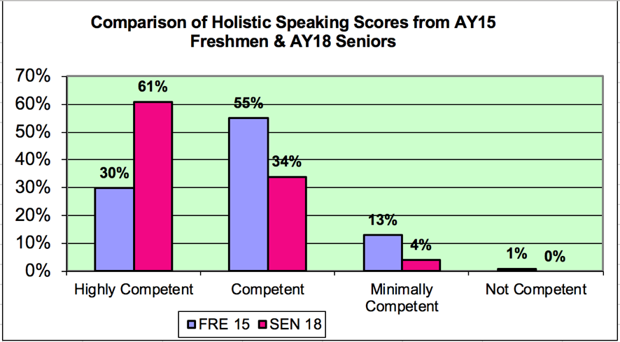
- This snapshot of freshmen compared to seniors after four years shows that seniors are rated as more competent speakers than freshmen, which shows an increase in speaking abilities while at EIU
  - We can make a reasonable assumption that many of the same students are included in both groups.
  - 61% of seniors were rated as highly competent while only 30% of freshmen reached this level.
  - 14 % of freshmen were rated minimally to not competent while only 4% of the seniors were at this level.

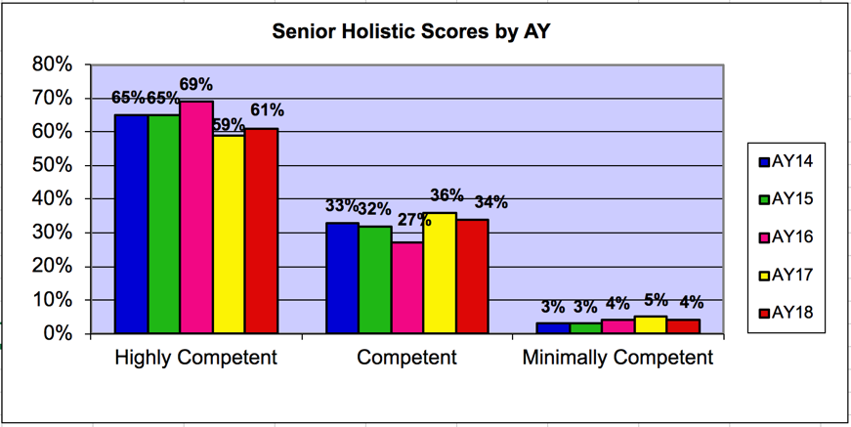
- A longitudinal view of seniors’ speaking ratings shows that ratings at the highly competent and competent levels fluctuate, but no more than 10% from one year to the next.
- The vast majority (95%-98% across the 5-year period) of our students are graduating with speaking skills rated in the competent to highly competent range.

Trait | AY 18 CMN 1310 Average | +/-  Previous AY | AY 18 EIU 4### Average | +/- Previous AY
Organization | 3.25 | -.17 | 3.57 | -.06
Language | 3.22 | -.15 | 3.58 | -.01
Material (Content) | 3.11 | -.06 | 3.57 | +.05
Analysis | 3.21 | +.01 | 3.49 | -.01
Nonverbal Del. | 2.89 | -.05 | 3.48 | +.06
Verbal Delivery | 2.96 | -.13 | 3.48 | -.01
Holistic Score | 3.10 | -.04 | 3.56 | +.03
The table shows mean sub-scores from AY18 in CMN 1310 and Senior Seminar as well as change in scores compared to AY17. In each category the highest rating is 4 (highly competent). In all categories, scores only fluctuate slightly, which is consistent with previous years. This shows that our speaking rubric is internally reliable.

NSSE (National Survey of Student Engagement) Data: NSSE data is collected every three years. The data below are from 2017 and are based on the response of EIU freshmen (N=222) and seniors (N-328).
- Question: In this academic year, how often have you given a course presentation?
  - EIU Freshmen = 57% often/very often compared to 37% of our regional peers
  - EIU Seniors = 64% often/very often compared to 59% of our regional peers
- Question: How much has your experience at this institution contributed to your knowledge, skills, and personal development in speaking clearly and effectively?
  - EIU Freshmen = 74% quite a bit/very much compared to 57% of our regional peers
  - EIU Seniors = 73% quite a bit/very much compared to 67% of our regional peers
Conclusions:
- Overall the data indicate growth in speaking skills at the university with most students rated as competent to highly competent their senior year (95%).
- NSSE data indicate that EIU freshman and seniors report giving more presentations and gaining more knowledge and skills about speaking and listening than their regional peers.
- Assessment of the speaking and listening learning goal at EIU occurs in 87% of undergraduate programs, which is an increase from 82% three years ago. Within the College structure of the EIU in AY18, at least 82% of the programs in each college have adopted the speaking and listening learning goal.

