Non-Accredited Programs
Assessment of Student Learning
All academic programs are required to create assessment plans that focus on continuous improvement, academic excellence, and articulate measurable student learning outcomes. The plans should be periodically reviewed and revised, as needed, by program faculty to reflect curriculum revisions, new interventions (such as course revisions), and enhanced measurements of student learning. Assessment is a sustained, ongoing, and reflective annual process that is student focused, documents change, and demonstrates that the program faculty engage in regular evidence-based discussions that contribute to continuous program improvement.
The assessment cycle at EIU requires the development of an assessment plan, annual data collection, and regular faculty engagement in the analysis of data on student outcomes. As such, assessment is an annual process of continuous improvement and refinement of academic programs, as well as learning outcomes. From a compliance perspective, all academic programs, including the general education program, will engage in a biennial review process. This biennial review process will require reports in Years 2 and 4 that include administrative review and feedback. Year 4 reporting and feedback will be more detailed and extensive. The assessment reports will be due to the Dean no later than October 15 or the first business day thereafter. Ordinarily, Dean feedback will be provided by November 15 and VPAA-designee feedback by December 15 (in Year 4-only). The materials will be archived online by the Academic Success Center.
Figure 1. Assessment as Continuous Improvement
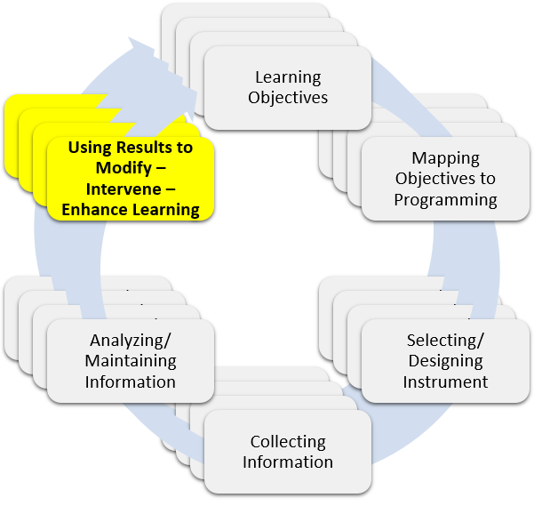
Year 2
Non-Accredited programs are required to submit the Year 2 Assessment Template. Additionally, the submission must include a Summary of the Assessment Data by SLO as an appendix. Programs may also include an optional cover memo (not to exceed 1 page). The cover letter might include any information or highlights the department believes would be important to demonstrate academic excellence and program quality.
The submitted materials will be reviewed by the Dean or their designee and feedback shared with the department. The program report and dean feedback will be archived by the Academic Success Center.
Year 4
Non-Accredited programs are required to submit a completed Year 4 Assessment Template and a Summary of the Assessment Data by SLO for the past 4 Years. The optional cover memo (not to exceed 1 page) may include any information or highlights the department believes would be important to demonstrate academic excellence and program quality.
The submitted materials will be reviewed by the Dean or their designee and feedback shared with the department. In addition, the report will be reviewed by a designee of the VP for Academic Affairs and archived by the Academic Success Center.

Year 2
Non-Accredited Programs Only
Student Learning Outcomes (SLOs) for Academic Programs
Please list all of the student learning outcomes for your program as articulated in the assessment plan.
1. [SLO#1]
2. [SLO#2]
3. [SLO#3], etc.

Overview of Measures/Instruments
SLO(s)  Note: Measures might be used for more than 1 SLO | ULG* | Measures/Instruments  Please include a clear description of the instrument including when and where it is administered | How is the information Used?  (include target score(s), results, and report if target(s) were met/not met/partially met for each instrument)
*Please reference any University Learning Goal(s) (ULG) that this SLO, if any, may address or assess. C=Critical Thinking, W=Writing & Critical Reading; S=Speaking and Listening; Q=Quantitative reasoning; R=Responsible Citizenship; NA=Not Applicable

Improvements and Changes Based on Assessment
1. Provide a short summary (1-2 paragraphs or bullets) of any curricular actions (revisions, additions, and so on) that were approved over the past two years as a result of reflecting on the student learning outcomes data. Are there any additional future changes, revisions, or interventions proposed or still pending?
2. Please provide a brief description or bulleted list of any improvements (or declines) observed/measured in student learning. Be sure to mention any intervention made that has not yet resulted in student improvement (if applicable).
3. Using the form below, please document annual faculty and committee engagement with the assessment process (such as the review of outcomes data, revisions/updates to assessment plan, and reaffirmation of SLOs).
History of Annual Review
Date of Annual Review | Individuals/Groups who Reviewed Plan | Results of the Review (i.e., reference proposed changes from #1 above, revised SLOs, etc...)

Dean Review & Feedback

_______________________________________________ ____________________
Dean or designee Date

Year 4
Student Learning Outcomes (SLOs) for Academic Programs
Please list all of the student learning outcomes for your program as articulated in the assessment plan.
1. [SLO#1]
2. [SLO#2]
3. [SLO#3], etc.

Overview of Measures/Instruments
SLO(s)  Note: Measures might be used for more than 1 SLO | ULG* | Measures/Instruments  Please include a clear description of the instrument including when and where it is administered | How is the information Used?  (include target score(s), results, and report if target(s) were met/not met/partially met for each instrument)
*Please reference any University Learning Goal(s) (ULG) that this SLO, if any, may address or assess. C=Critical Thinking, W=Writing & Critical Reading; S=Speaking and Listening; Q=Quantitative reasoning; R=Responsible Citizenship; NA=Not Applicable

Improvements and Changes Based on Assessment
1. Provide a short summary (1-2 paragraphs or bullets) of any curricular actions (revisions, additions, and so on) that were approved over the past four years as a result of reflecting on the student learning outcomes data. Are there any additional future changes, revisions, or interventions proposed or still pending?
2. Please provide a brief description or bulleted list of any improvements observed/measured in student learning over the past four years. Be sure to mention any intervention made that has not yet resulted in student improvement (if applicable).
3. Using the form below, please document annual faculty and committee engagement with the assessment process (such as the review of outcomes data, revisions/updates to assessment plan, and reaffirmation of SLOs).
History of Annual Review
Date of Annual Review | Individuals/Groups who Reviewed Plan | Results of the Review (i.e., reference proposed changes from #1 above, revised SLOs, etc...)

Dean Review & Feedback

_______________________________________________ ____________________
Dean or designee Date

Academic Affairs – Academic Success Center Review & Feedback

_______________________________________________ ____________________
Executive Director Date

Student Learning Outcomes (SLOs) are program specific learning outcomes or competencies that are assessed by the program. SLOs are expected to be linked to current discipline or professional standards. Please note, SLOs may map to one or more University Learning Goals.
Based on Walvoord, B. 2010. Assessment Clear and Simple: A Practical Guide for Institutions, Departments, & General Education, 2nd Edition. San Francisco: Jossey-Bass-Wiley.
With permission of the VP for Academic Affairs or designee, programs may substitute the IBHE program review (not the short form) in place of the Year 2 or 4 report, if it falls within the same calendar year, and if these documents substantively discuss assessment, outcomes, and data.

