

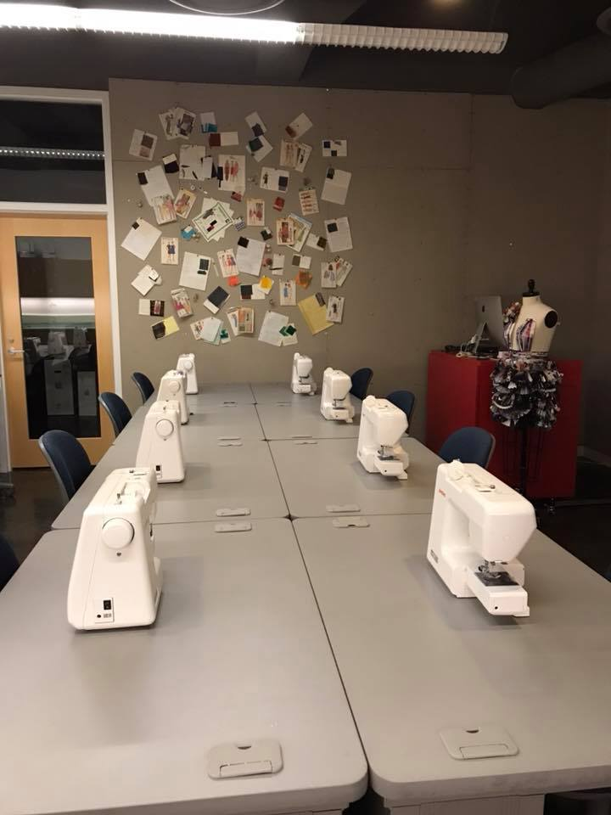
MAJOR

55 credit hours, B.S.

2020-2021 Undergraduate Catalog
eiu.edu/art

REQUIRED COURSES:

ART 1110 – Two-Dimensional Foundations (3)
ART 1111 – Three-Dimensional Foundations (3)
ART 2601G – Art in the Pre-Modern Era (3) OR
ART 2602G – Art in the Modern Era (3)
ART 2749 – Professional Practices (1)
ART 2910 – Introduction to Graphic Design (3)
FMD 1244 – Survey of Fashion (3)
FMD 2233 – Introduction to Fashion Merchandising (3)
FMD 2234 – Apparel Construction (3)
FMD 2244 – Fashion & Fiber (3)
FMD 2245 – Fashion E-tailing (3)
FMD 3200 – The History of Fashion (3)
FMD 3233 – Retail Mathematics (3)
FMD 3244 – Global Fashion Forecasting (3)
FMD 3838 – Apparel Development and Design (3)
FMD 4275 – Internship in Fashion Merchandising and Design (3)
FMD 4772 – Sustainability and Social Change in Fashion (3)
FMD 4848 – Cultural Aspects of Fashion and Dress (3)
FMD 4926 – Visual Merchandising (3)
PSY 1879G – Introductory Psychology (3)

The classes in this curriculum allow students to select a minor to complement their degree plan and career path in consultation with an academic advisor and Fashion Merchandising + Design faculty.

