Regulation of Metabolism and Body Composition
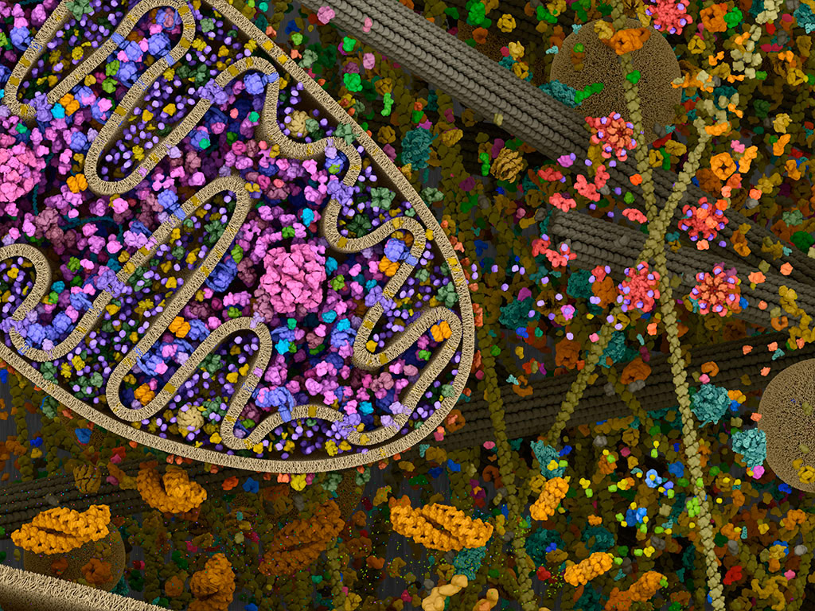
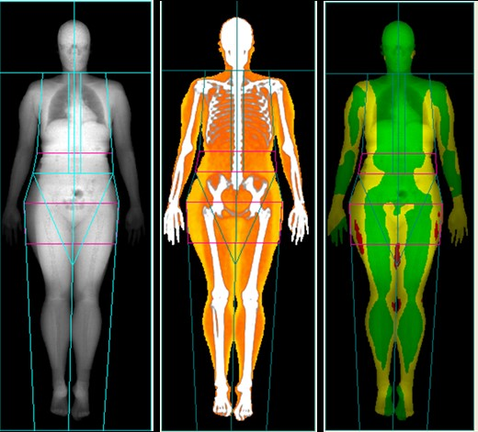
KSS 5280
Kinesiology & Sports Studies -- Eastern Illinois University
Spring 2018

Instructor: Brian Pritschet, Ph.D.
Office: 2207 Lantz Phone: 581-2215 (KSS Office)
Office Hours: Monday 10-11 am, Tuesday 10-11 am, Wednesday 3-4 pm & Thursday 1-2 pm Other times by appointment
e-mail: D2L (submission of course materials) and blpritschet@eiu.edu

Course Description:
Study of the regulation and assessment of energy metabolism during and following exercise, including the influence of diet and training on exercise metabolism. Also included are assessment of body composition and obesity, the effect of exercise on body composition and the role of exercise in weight regulation.

Course Objectives:
1. Understand how energy is derived for exercise, with emphasis on aerobic and anaerobic cellular metabolism.
2. Demonstrate the measurement of energy expenditure during rest and physical activity.
3. Design an experiment to explore how metabolism is affected by the intensity and duration of exercise.
4. Be able to explain how exercise metabolism is affected by diet before, during and following physical activity.
5. Be able to explain the concept of obesity and how it is assessed.
6. Understand the underlying theory behind laboratory and field techniques to assess body composition.
7. Discuss the role of obesity in health.
8. Explain the relationship of energy balance and weight control, and explain the role of physical activity.
9. Understand the effect of physical activity on body composition.

Evaluation:
Quizzes 5-10 points each
Assignments 5-15 points each
Exams 40 points each
Final Exam 50 points
Article Presentation 10 points
Projects 30 points each

Grading Scale:
A ≥ 90% of total points
B 80-89%
C 70-79%
D 60-69
F <60%

Text: Exercise Physiology: Nutrition, Energy & Human Performance (8th Ed.). McArdle, Katch & Katch

It is the student’s responsibility to be aware of all course assignments and exams through attendance in class and by checking D2L regularly and frequently. Missing an assignment because you failed to check D2L or to attend class is not a legitimate excuse! All assignments must be turned in by the announced due date unless you can provide an official University recognized excuse. A 50% penalty will be assessed for work that is turned in after the due date/time within 24 hours, after this, work will not be accepted. The opportunity to make up work that is late due to extenuating circumstances is at the discretion of the instructor. No make-up exams, quizzes, or assignments will be given without appropriate documentation of a university accepted absence excuse.
D2L will be utilized in this course for the following: Powerpoint slides (incomplete), Online quizzes/exams, assignment submissions, readings, resources and course communications. YOU are responsible for being aware and making use of these tools and resources.
D2L based assignments sent via e-mail attachment instead of submission through ‘Dropbox’ will NOT be accepted unless indicated otherwise by the instructor or by permission.
This is a GRADUATE level course, attendance and participation are expected! Successful performance in this course will not only require your presence and active engagement during class time but also regular study and review of your notes and the textbook.
There will be NO extra credit offered in this course.

Quizzes Quizzes may or may not be announced in advance! These quizzes will include multiple choice &/or short answer questions. Quizzes will be given ~ every two weeks.
Article Presentation: Individual summary of a research article related to an assigned general course topic.
Metabolism Teaching Project
Develop a creative powerpoint presentation to illustrate a specific aspect of metabolism/bioenergetics. Will be shared with the class.
Body Composition Project
Self-assessment of body composition and physique with interpretation and critical comparison of techniques.

Exams Approximately 3 exams (about every 4-5 weeks) covering a specific portion of the course.

Final Exam The final exam will be comprehensive and is scheduled for:
Thursday, May 3rd 10:15 am – 12:15 pm

Please turn phones and music players off and remove earpieces/headphones prior to the start of class and leave them in your pocket or backpacks (they should not be on your desk or in your lap).
There should be no texting during class!
The use of a laptop computer or tablet device to view or take notes is permissible but discouraged; however, please do not use these for anything other than class related functions (ø facebook, games, twitter, browsing, etc.) (Research suggests that less information is retained when tablets/computers are used to take notes compared with writing)
Individuals who habitually violate these guidelines will be asked to leave the classroom and will need to meet with the instructor prior to being allowed to return.

It is expected that all students will follow the guidelines set forth in the EIU Student Conduct Code (http://www.eiu.edu/judicial/studentconductcode.php). Violations will be reported to the Office of Student Standards.
Academic honesty is expected, cheating in any form will not be tolerated! This includes work assigned through D2L!

ALL Work submitted via D2L should be completed independently unless otherwise indicated by the instructor.

The information contained in this syllabus is subject to change at the discretion of the instructor

- If you are a student with a documented disability in need of accommodations to fully participate in this class, please contact the Office of Student Disability Services (OSDS). All accommodations must be approved through OSDS. Please stop by Ninth Street Hall, Room 2006 or coll 217-581-6583 to make an appointment.

- Students who are having difficulty achieving their academic goals are encouraged to contact the Student Success Center for assistance with time management, test taking, avoiding procrastination, setting goals and other skills to support academic achievement (www.eiu.edu/~success). The Student Success Center provides individualized consultations. To make an appointment, go to 9th Street Hall, Room 1302 or call 581-6696.

Tentative Schedule
WEEK | TOPIC | Approx. Quiz/Exam  Schedule
1 | Introduction to Energy Transfer (Chapter 5)
2 | Energy Nutrients (Chapter 1) | Quiz
3 | Role of Vitamins, Minerals & Water (Chapter 2)  Energy Transfer in the Body (Chapter 6)
4 | Energy Transfer in the Body | Exam
5 | Energy Transfer in the Body  Energy Transfer during Exercise (Chapter 7)
6 | Energy Transfer during Exercise | Quiz
7 | Energy Transfer during Exercise | Metabolism Project
8 | Energy Expenditure  Measurement of Energy Expenditure (Chapter 8) | Exam
9 | Introduction to the Assessment of Body Composition & Physique
10 | Techniques for the Assessment of Body Composition (Ch 28)
11 | Techniques for the Assessment of Body Composition | Quiz
12 | Obesity (Ch 30, Pt 1)
13 | Energy Balance & Weight Control (Ch 30, Pt 2) | Exam
14 | Effects of Physical Activity on Body Composition (Ch 30, Pt 2)
15 | Continued….. | Quiz  Body Comp. Project
16 | Final Exam --- May 3rd @ 10:15 am | Final

