Microsoft Teams - Calling Quick Reference Guide
Using The Teams App or Web Client

Users have two options when using Microsoft Teams: the Teams desktop app or the Teams web client. The web client is found at the landing page when logging into Panthermail. To determine if the desktop app is installed. Go to the Start menu by clicking the Windows logo on the lower left corner of your screen and search for Teams. On Mac, go to the Applications folder and click Microsoft Teams. On mobile device, tap the Teams icon. If it is already installed, then you are all set! Sign in with your EIU username and password.

If the Teams desktop app is not installed, go to https://www.microsoft.com/en-us/microsoft-teams/download-app to install it. Make sure to install the “Teams for Work or School” app. If you need assistance, please contact the Help Desk at 217-581-4357

Secondary Ringer is a recommended feature that allows Teams to ring an inbound call or chat on multiple devices. If you have a headset and do not wish to wear it at all times, you will want to activate the secondary ringer so your speakers, laptop, desktop, etc will notify of a call/chat.

Configuring a Secondary Ringer – Recommended for Headset Users

- In your Teams client, click on the three dots next to your profile picture
- Go to Settings > Devices.
- Under Secondary ringer, choose which output device you would like to ring when receiving calls.

Setup Microsoft Teams Voicemail
- Click on the three dots next to your profile picture within the Teams application.

- While in Settings, choose Calls and then click Configure Voicemail.
- You will now have the several options to personalize your voicemail settings (record a voicemail, out of office greetings, etc.)

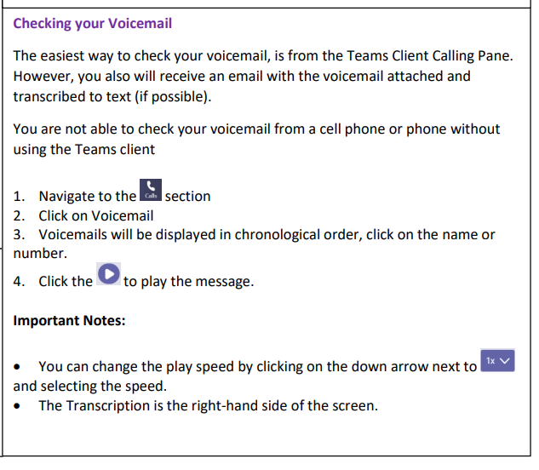

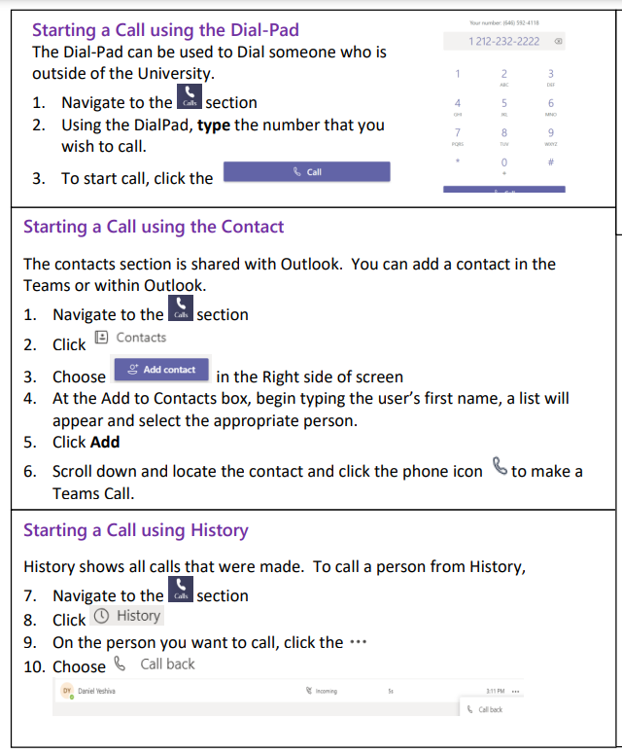
Making and Receiving Calls

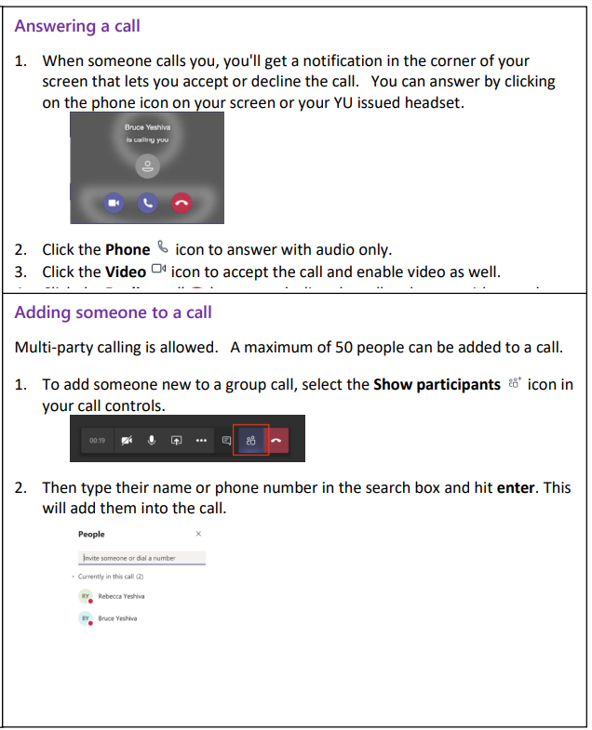

Set up call forwarding
To start forwarding your calls, select Settings and more next to your profile picture at the top of Teams. Then select Settings > Calls.
Under Call answering rules, choose Forward my calls, and then select where you want your forwarded calls to go: voicemail, another person, or a call group.
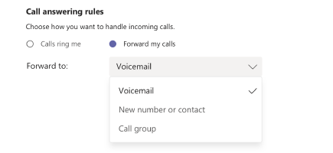
You can also find these settings (whenever you're in the Calls area) by selecting Don't forward (or Forward to voicemail, etc.) in the lower-left of Teams.
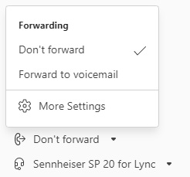

Call sharing and Call Groups (replaces call pick up we currently have on campus and line appearances so others can pick up your line)
The call sharing and call group features of Microsoft Teams let users share their incoming calls with colleagues so that the colleagues can answer calls that occur while the user is unavailable.
1. Select next to your profile picture at the top of Teams. Then select Settings > Calls.
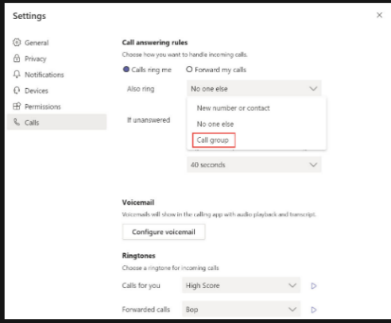
2. Then in the dropdown, choose “call group”

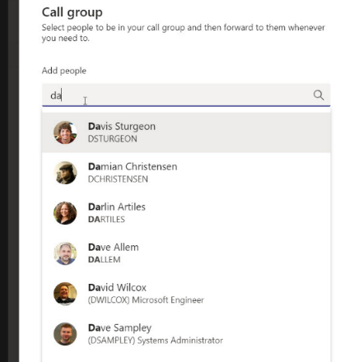
3. Add the names of the people you want to add to this call group
- You can have a MAX of 25 users in your call group
- You can have a MAX of 32,768 call groups

4. At the bottom of the screen, pick the order you want people in your call group to receive your calls.
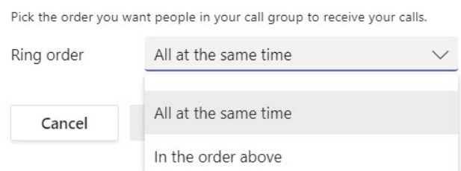

5. Press Save

CALL QUEUES (main departmental lines are set up as call queues) In a call queue, calls are distributed to the people in the queue, known as agents. Queues provide a greeting message, music while people are waiting on hold in the queue, call routing to agents and handling options for queue overflow.
How to opt-in and opt-out of a call queue (this is only available if your Department Head/Office Manger has opted to turn this feature on)
- Open Microsoft Teams.
- In the top right, click the three horizontal dots.
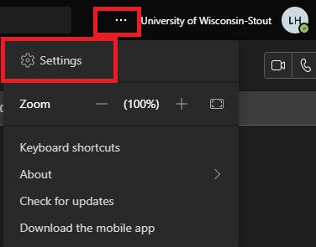
- Click Settings.
- In the left column, select Calls.
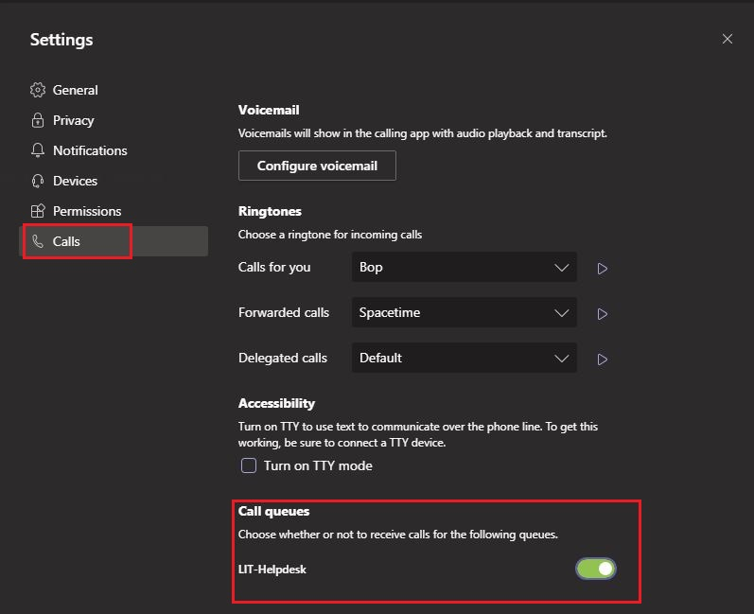
Scroll to the bottom of the settings and use the toggle to turn on or off any call queues you are a member of
Greetings for Call Queues and Auto Attendants
If applicable, each department will have an administrator(s) that controls the voicemail greetings for the departments Call Queue and Auto Attendants

1. Select next to your profile picture at the top of Teams. Then select Settings > Calls. Scroll to the bottom to Call queue or auto attendant. Click on the one you wish to record or change a greeting.
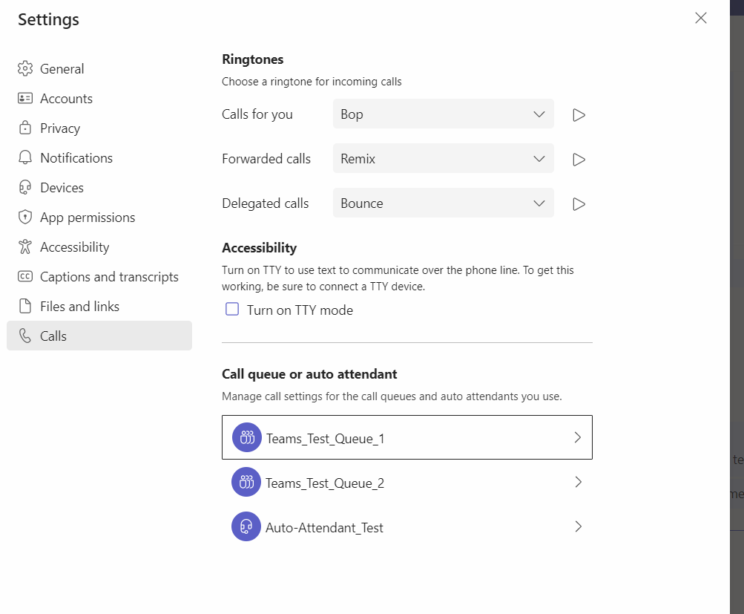
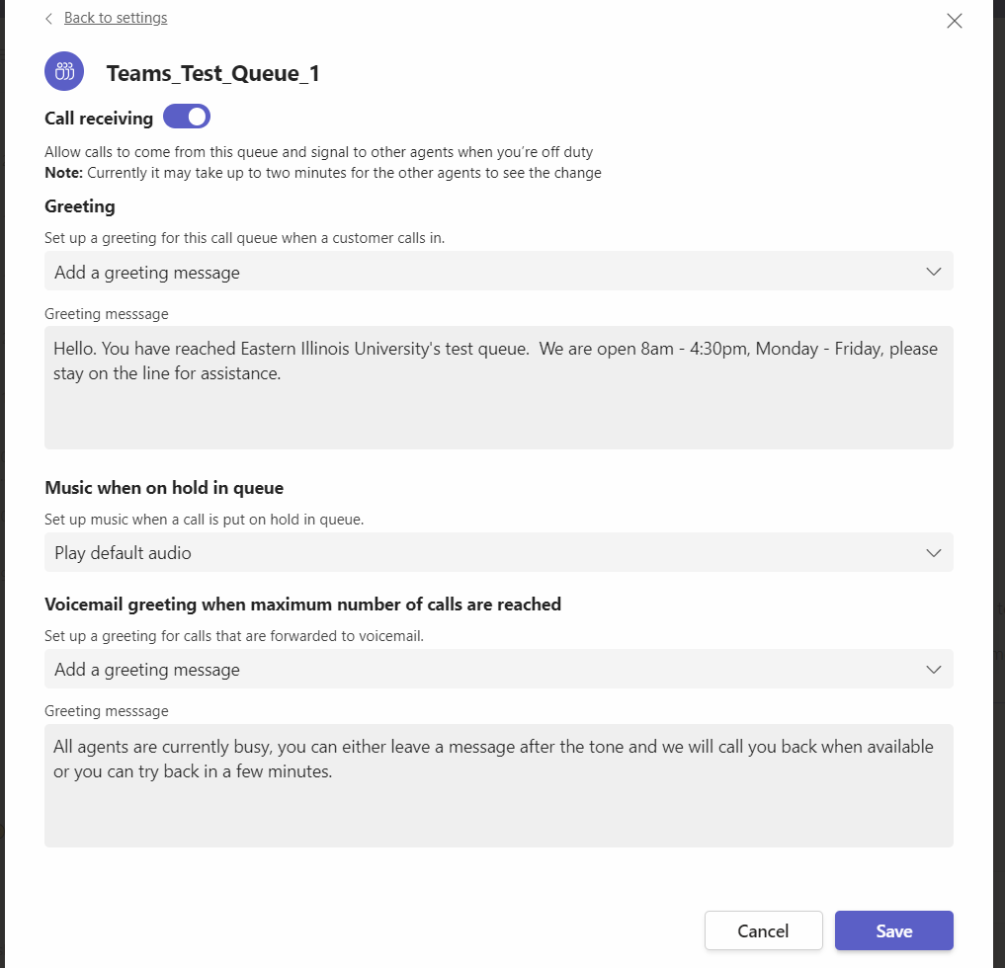

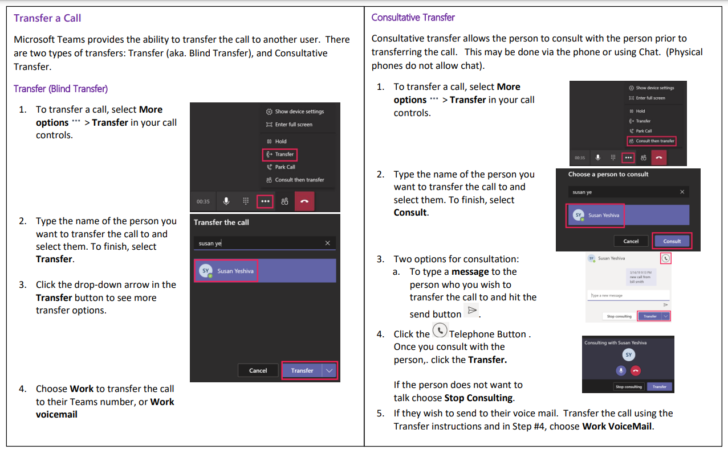
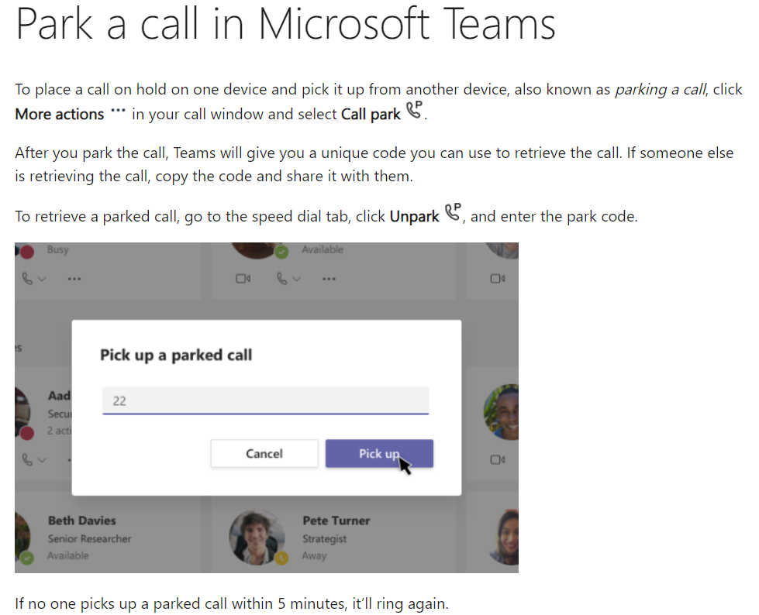
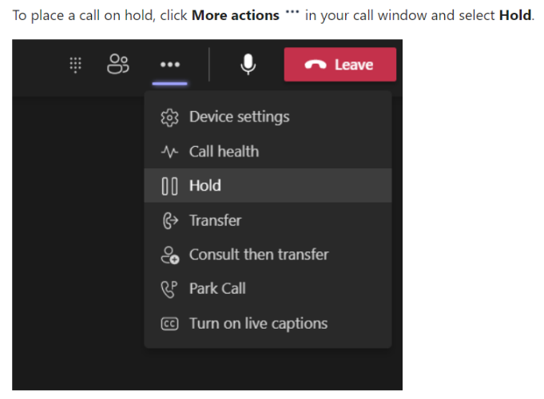
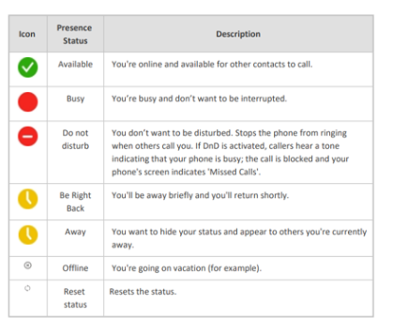

Add a delegate (To receive and make calls on your behalf)
You can pick users in Teams to be your delegate—to receive and make calls on your behalf. When you add a delegate, you’re essentially sharing your phone line with them, so they can see and share all of your calls.
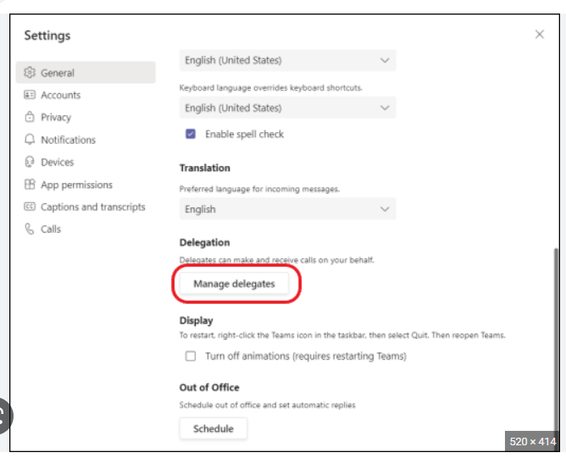
To designate a delegate, select Settings and more next to your profile picture at the top of Teams and choose Settings > General. Under Delegation, select Manage delegates. There you can see who you're a delegate for and add and remove your own delegates.

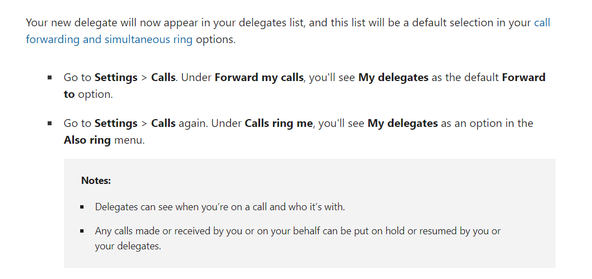

Change status to inform others you are away or busy
If you want to make sure people know when you’re busy or away from your desk, set your status in Teams. The little dot on your profile indicates if you’re available or not.
Teams will automatically set the status in some cases, like when you’re in a call or in a Teams meeting. To explicitly set it yourself, go to your profile at the top of Teams and select one from the list.
When you want to change your status for a specific period of time—for example, to set "Do not disturb" for an hour of concentrated work—you can set a duration so that Teams will automatically reset your status at the end of the allotted time.
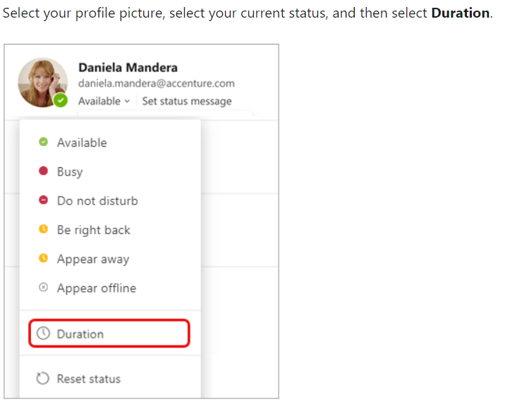
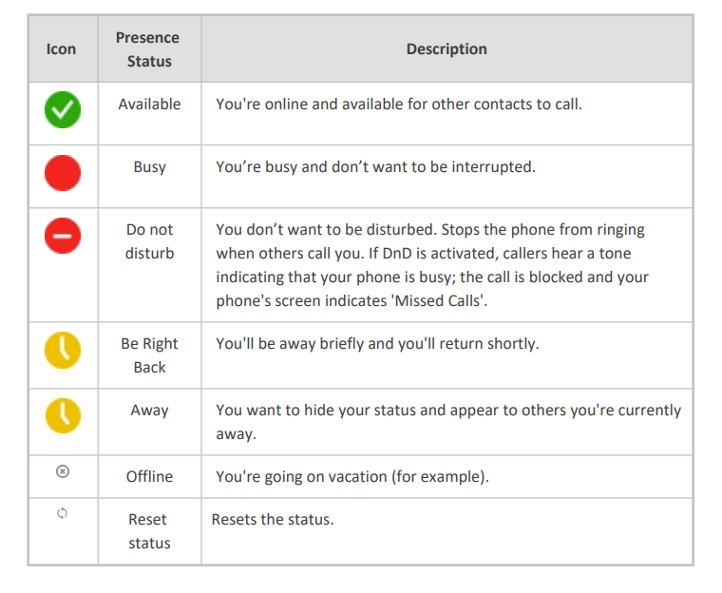
Teams on your Mobile Device
Chat or make calls from anywhere - at work, at home, or on the go by installing Microsoft Teams on your cellular device and signing in with your EIU credentials.
“Teams requires network connection or internet for you to be able to use it for communication. It will not work without network connection. You can use wifi or mobile data on your cellular device. It does not use “calling minutes” from your plan.”

Download the Teams Mobile App from the iOS App Store or Google Play Store.
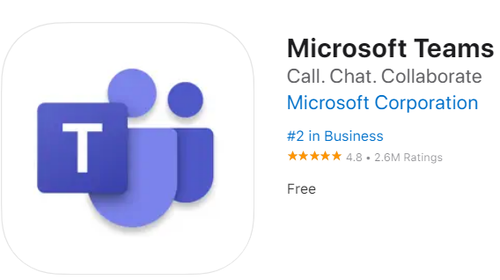

Troubleshooting Steps for Teams Call Quality Issues
- Headset Users: Disconnect the headset and see if issue continues using the laptop’s onboard mic and speakers or an external webcam if applicable to see if call quality changes.
- Hang up and call them back to see if call quality changes.
- After the call, run a call test to hear your own audio. In Teams > go to the three dots next to your profile … > settings > Devices > Make a test call (you will record a short message and be able to hear it back.) Test headset, laptop, external webcam, etc. This will help you determine the best device for call quality.

To Report an Issue with Teams Voice
Send an email to techsupport@eiu.edu
Please provide the below information, as well as, any other information you feel is relevant
- Date and time of the call
- Your name and 581#
- Phone number of the person you were calling
- What was each person using? Headset, Desk Phone, Speaker Phone, Cellular Phone
- (if applicable) Laptop or desktop computer?
- Where were both people located? In the office, at home, Starbucks, etc.

If you have any questions or need assistance with Microsoft Teams, please contact the Help Desk at 217-581-4357
or via email at techsupport@eiu.edu

