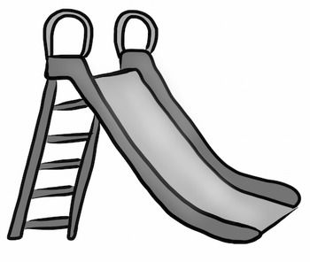

1. Read and discuss *“The Recess Queen”* by Alexis O’Neill and Illustrated by Laura Huliska-Beith.
2. Brainstorm a list of positive behaviors that we see on the playground.
3. Make a list of positive things that we can do on the playground. Write them on the slide.

<http://www.fantasticfunandlearning.com/character-lessons-bullying-recess-queen.html>