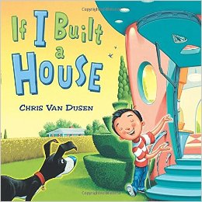
Title: “If I Built a House”
Author: Chris Van Dusen
Grade Level: K-1st Grade

Synopsis:
Jack is a young boy with a huge imagination. His dream house design is whacky, fun, and sure to make you laugh. From spinning sofas to racetrack rooms, Jack imagines it all. Jacks’ imagination is quite contagious, because he gets every reader dreaming of their own house design.
Resources:
- http://snippetygibbet.blogspot.com/2011/02/first-grade-architecture.html
- http://innerchildfun.com/2014/10/rainy-day-fun-paper-bag-houses.html
Materials:
- 1 Paper lunch bag per student
- Variety of colored construction paper
- Crayons, markers, colored pencils, paint
- Glue
- Scissors (decorative ones too)
- Old newspaper
- Stapler
Activity: (Introduces the meaning of architecture)
- After reading “If I Built a House” students will design paper bag houses.
- Fill the paper lunch bag ½ full of old newspaper
- Roll down the top opening of the bag and staple it to hold in place
- To make the roof fold a piece of construction paper over the top and glue it down.
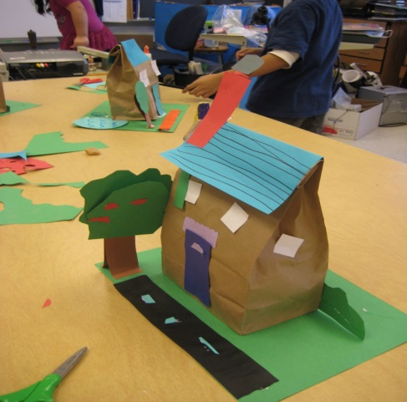
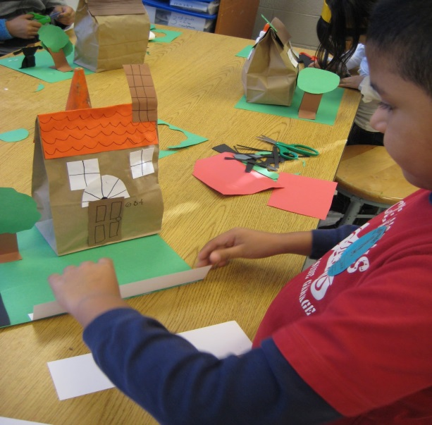
- Students can use the various art supplies to add their own unique details to their house.

