Comparisons of Qualitative Data from Alumni Surveys

In summer 2011, the five years from graduation survey was sent to graduates from 2006. Postcards were sent to the alumni alerting them to expect a survey from the institution. Then, approximately three weeks later, the survey arrived with a letter from the President requesting its completion. A month later, a second letter and survey were mailed to the people who had not yet responded.

There were 799 alumni surveys returned out of 2,159 reachable graduates for a 37% return rate.

The following table illustrates the comment categories from the question, What had the most positive impact on you during your time at Eastern? Response categories are given for the last five years of survey data.

Topics | 1 Year Out  2006 Graduates  (2007 Survey) | 5 Years Out  2003 Graduates (2008 Survey) | 9 Years Out  2000 Graduates (2009 Survey) | 1 Year Out  2009 Graduates (2010 Survey) | 5 Years Out  2006 Graduates (2011 Survey)
Professors/advisors | 45% | 41% | 47% | 53% | 45%
Programs/courses | 35% | 34% | 38% | 28% | 36%
Social life | 24% | 28% | 18% | 21% | 24%
Co-curriculum | 9% | 8% | 13% | 14% | 13%
Community and facilities | 10% | 8% | 8% | 10% | 9%
Personal growth | 5% | 6% | 7% | 3% | 4%

Relationships with professors remained the highest category of positive comments followed by specific programs and courses. Comments related to social life (parties, friends, Greek life, Housing) rose 3% from the previous year’s administration while the impact from involvement in the co-curriculum (athletics, RSOs, campus activities) dropped only 1%. The positive nature of personal growth was at 4% while positive comments about the community and facilities stayed in the 8-10% range.

The chart below compares the percentage of received positive impact comments for the last three survey years.

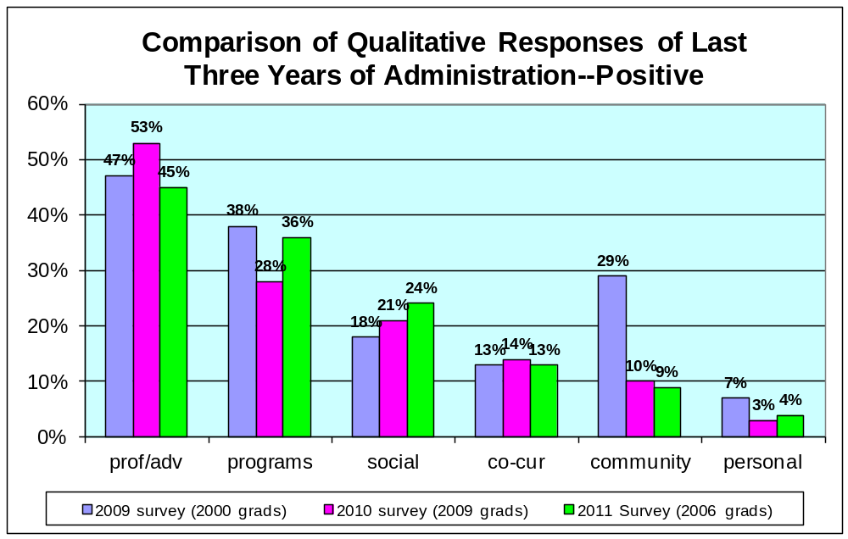

The class of 2006 was also surveyed at 1 year out in 2007, and the answers to this question fell into very similar categories with only the co-curriculum showing an increase of more than 1 percentage point. The chart below compares the 2007 (one year out) responses to the 2011 (five years out) responses to both the positive and negative impact questions.

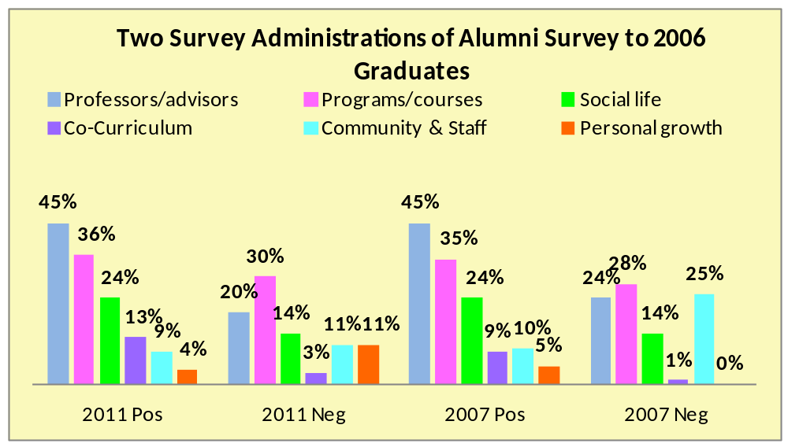

While the response categories to the positive impact question remain extremely similar, the responses to the negative impact have changed. None of the alumni surveyed in 2007 indicated any personal negative impacts whereas 11% of the 2011 responses fell into this category (comments were related to time away from family, long commutes, illness, and so forth). The number of negative comments related to the community or facilities dropped by 14% in 2011; these comments are related to Charleston’s size and limitations as well as campus facilities and construction. From this change in comments we can infer that inconveniences

related to construction or lack of shopping do not stay with alumni. Negative comments concerning faculty members or advisors also decreased by 4% with the other categories remaining very similar in the two administrations.

The following table illustrates the comment categories from the question, What had the most negative impact on you during your time at Eastern? Response categories are given for the last five years of survey data.

Topics | 1 Year Out  2006 Graduates (2007 Survey) | 5 Years Out  2003 Graduates (2008 Survey) | 9 Years Out 2000 Graduates (2009 Survey) | 1 Year Out  2009 Graduates (2010 Survey) | 5 Years Out 2006 Graduates (2011 Survey)
Professors & advisors | 24% | 16% | 14% | 23% | 20%
Programs & courses | 28% | 27% | 26% | 22% | 30%
Social life | 14% | 13% | 15% | 12% | 14%
Co-curriculum | 1% | 1% | 2% | <1% | 3%
Community & facilities | 25% | 11% | 12% | 14% | 11%
Personal growth/issues | 0 | 9% | 7% | 11% | 11%
Nothing Negative | 15% | 30% | 30% | 23% | 9%

This year’s survey respondents had more negative comments related to programs and courses than any other category. Many of these responses related to major and concentration options being limited, not being required to complete an internship or having limited availability of such work-related experiences, gaps in education related to job performance, and preparation for the work force.

The chart below compares the percentage of received negative impact comments for the last three years of surveys. “Nothing negative” to say about EIU remains one of the highest categories, but it does tie with the relationship with professors and advisors followed closely by specific programs/majors/scheduling. The nothing negative cateogry has declined quite a bit. Previous iterations of this survey administration saw numerous “N/A” or “none” comments to the negative impact question. This year’s respondents tended to leave the question blank; only 53% (421) of the people who returned a survey chose to answer this question. Of those who did respond, 38 (9%) gave additional positive comments.

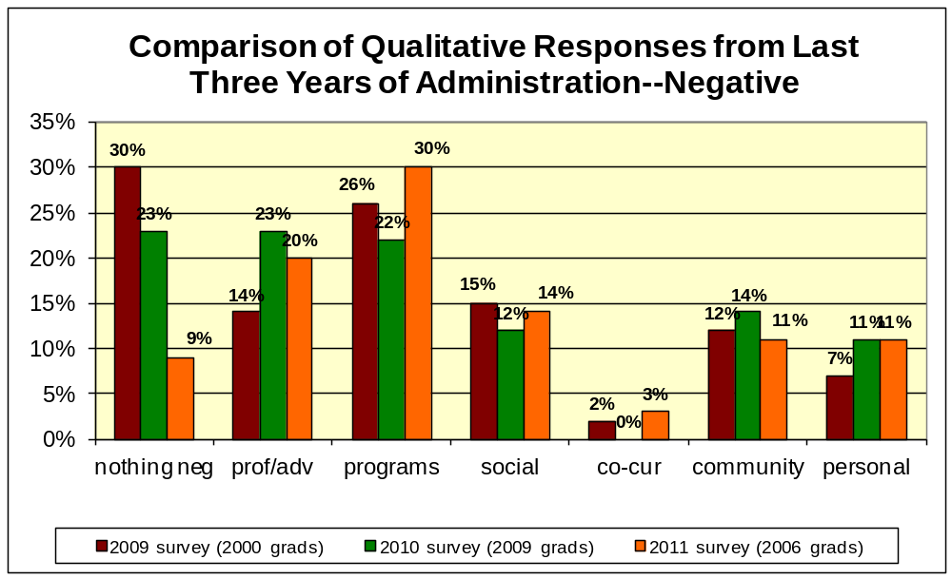

The following chart shows four cohort groups of alumni surveyed five years after they graduated; surveys were conducted in 2002, 2005, 2008, and 2011. Similar topics were commented upon as having the most positive impact on former students’ time at Eastern with the relationship with faculty/advisors being the most valued, followed by programs/major/degree, and then social life. Although the percentages fluctuate, these topics remain consistent across the graduating years.

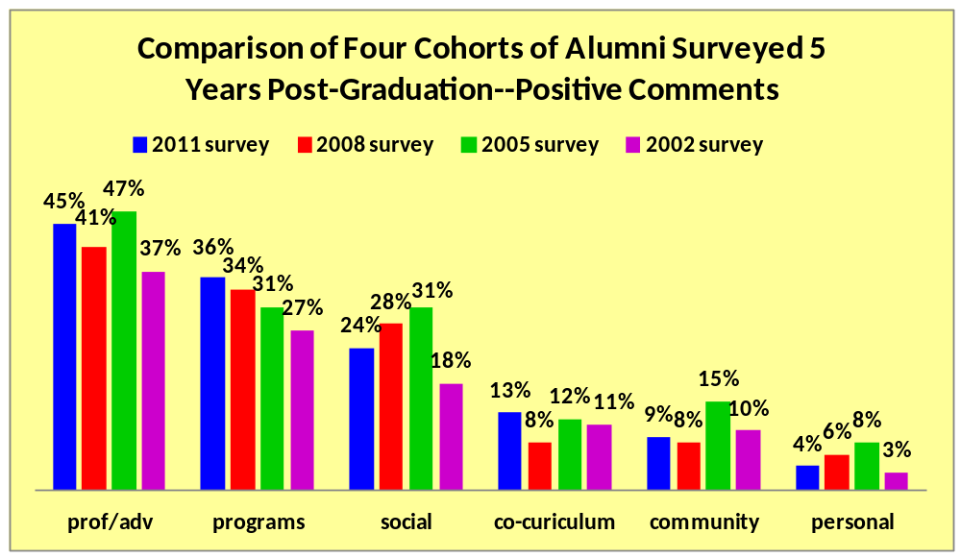

Concerns or issues that had the most negative impact on former students’ time at Eastern varied a bit more than the positive topics. The most recent survey respondents listed specific programs/degree 10% higher than any other category. Negative comments were more evenly distributed among the categories from the Many of the negative comments in previous years related to the construction of the library and fine arts center, which are reflected in comments from the 2008 and 2011 surveys of the classes of 2003 and 2006.

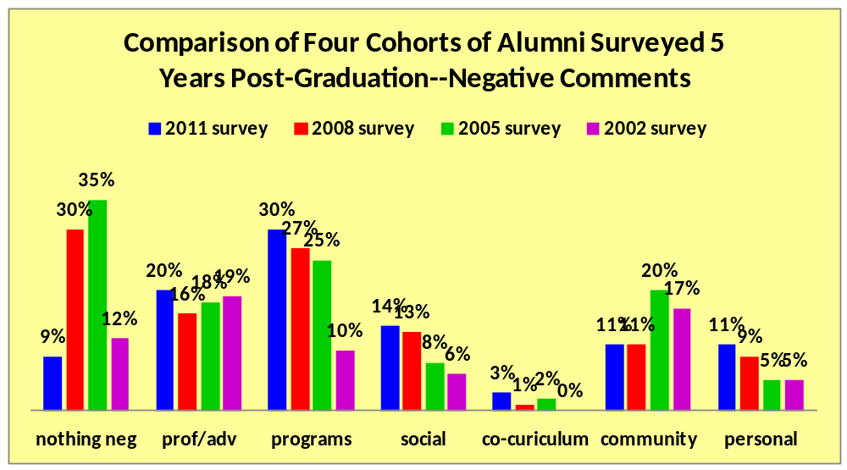

While some of the negative comments relate to issues over which Eastern has no control—the location and size of the town, for example—some of these comments may inform what we can do to make the education received and the overall EIU experience as positive as possible. Positive comments re-affirm the attributes that have attracted generations of students: the one-on-one relationships with advisors and faculty members; the excellent education, including study abroad and practicum experiences; the variety of co-curricular experiences; and the personal touches for which many alumni have expressed gratitude across several iterations of the alumni survey.

