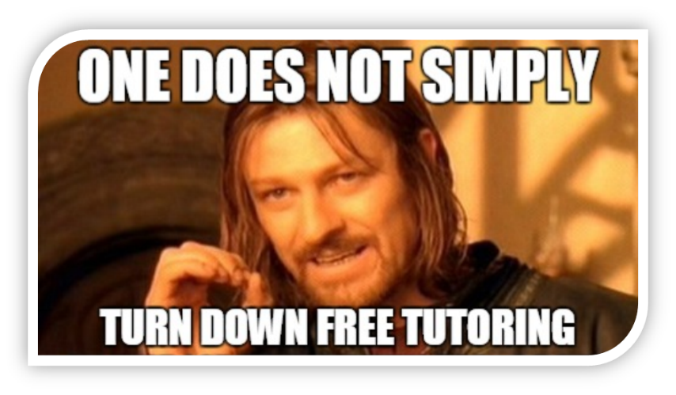

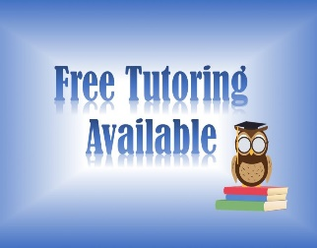

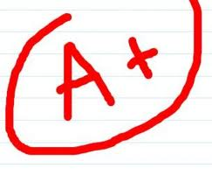

College is hard. Let us help!

We offer tutoring for:
- BIO 1001G: Biological Principles/Issues
- BIO 1500 : General Biology I
- BIO 1500G: General Biology II
- BIO 2210: Anatomy and Phys I
- BIO 2220: Anatomy and Phys II
- BIO 3120: Molecular and Cell Biology
- BIO 3200: Genetics
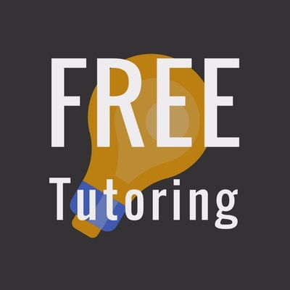
- BIO 3180: Ecology and Evolution

Tuesday and Thursday from 6-8 pm
Thursday from 11:30 -1 pm
Life Science Bldg. Room 2130 (annex, 2nd floor)
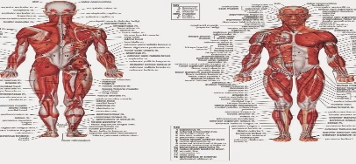
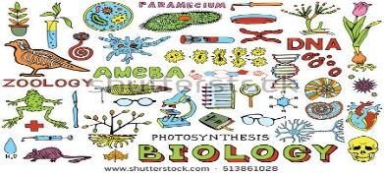
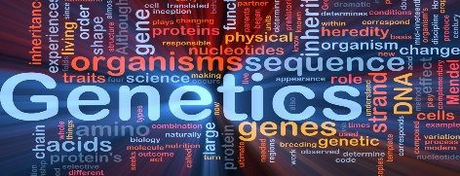
Please bring your own notes/textbooks so that we can help you!

