

MINOR

**18 credit hours**

2020-2021 Undergraduate Catalog

eiu.edu/art

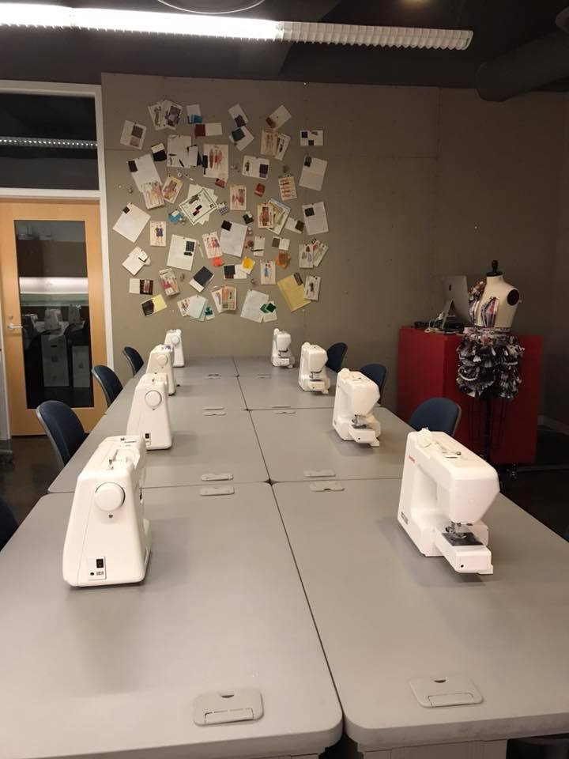REQUIRED COURSES:

**A) Complete the following (9 semester hours):**

FMD 2233 – Introduction to Fashion Merchandising (3)

FMD 2234 – Apparel Construction (3)

FMD 2244 – Fashion & Fiber (3)

**B) Complete 9 semester hours from the following courses:**

*Additional three (3) courses from the following list to fulfill the Fashion Merchandising and Design Minor, at least one of which must have a FMD prefix:*

ART 1110 – Two-Dimensional Foundations (3)

ART 1111 – Three-Dimensional Foundations (3)

ART 2910 – Introduction to Graphic Design (3)

 BUS 3100 – Survey of Marketing Principles (3)

FMD 1244 – Survey of Fashion (3)

FMD 2245 – Fashion E-tailing (3)

FMD 3200 – The History of Fashion (3)

FMD 3233 – Retail Mathematics (3)

FMD 3244 – Global Fashion Forecasting (3)

FMD 3838 – Apparel Development and Design (3)

FMD 4772 – Sustainability and Social Change in Fashion (3)

FMD 4848 – Cultural Aspects of Fashion and Dress (3)

FMD 4926 – Visual Merchandising (3)