

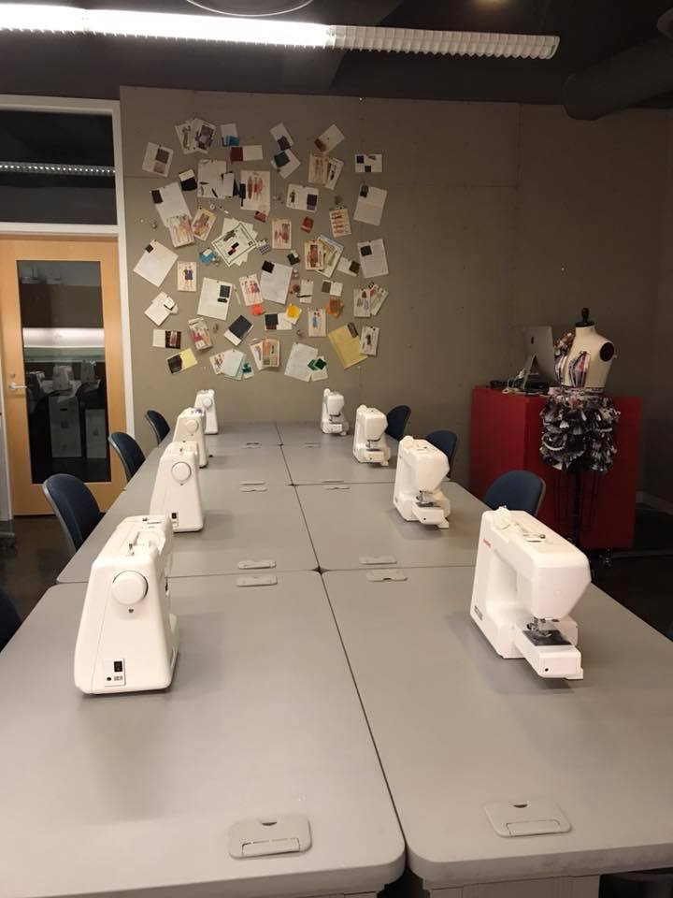MAJOR

**55 credit hours, B.S.**

2020-2021 Undergraduate Catalog

eiu.edu/art

REQUIRED COURSES:

ART 1110 – Two-Dimensional Foundations (3)

ART 1111 – Three-Dimensional Foundations (3)

ART 2601G – Art in the Pre-Modern Era (3) *OR*

ART 2602G – Art in the Modern Era (3)

ART 2749 – Professional Practices (1)

ART 2910 – Introduction to Graphic Design (3)

[FMD 1244 – Survey of Fashion](http://catalog.eiu.edu/preview_program.php?catoid=32&poid=4738&print) (3)

[FMD 2233 – Introduction to Fashion Merchandising](http://catalog.eiu.edu/preview_program.php?catoid=32&poid=4738&print) (3)

[FMD 2234 – Apparel Construction](http://catalog.eiu.edu/preview_program.php?catoid=32&poid=4738&print) (3)

FMD 2244 – Fashion & Fiber (3)

FMD 2245 – Fashion E-tailing (3)

FMD 3200 – The History of Fashion (3)

FMD 3233 – Retail Mathematics (3)

[FMD 3244 – Global Fashion Forecasting](http://catalog.eiu.edu/preview_program.php?catoid=32&poid=4738&print) (3)

FMD 3838 – Apparel Development and Design (3)

FMD 4275 – Internship in Fashion Merchandising and Design (3)

FMD 4772 – Sustainability and Social Change in Fashion (3)

[FMD 4848 – Cultural Aspects of Fashion and Dress](http://catalog.eiu.edu/preview_program.php?catoid=32&poid=4738&print) (3)

[FMD 4926 – Visual Merchandising](http://catalog.eiu.edu/preview_program.php?catoid=32&poid=4738&print) (3)

[PSY 1879G – Introductory Psychology](http://catalog.eiu.edu/preview_program.php?catoid=32&poid=4738&print) (3)

**The classes in this curriculum allow students to select a minor to complement their degree plan and career path in consultation with an academic advisor and Fashion Merchandising + Design faculty.**